RIBBLE VALLEY BOROUGH COUNCIL
INFORMATION
REPORT TO ACCOUNTS AND AUDIT COMMITTEE
Agenda Item No
meeting date: 25 MARCH 2009
title: CAA/USE OF RESOURCES 2009 UPDATE
submitted by: DIRECTOR OF RESOURCES
principal author: JANE PEARSON

1 PURPOSE

  - To update members with the latest position regarding our Use of Resources assessment for 2009.

  - Relevance to the Council’s ambitions and priorities:

- This report links clearly to the council’s overarching ambition to be a well-managed council providing efficient services based on identified customer needs

2 BACKGROUND

  - As reported to your last meeting there are considerable changes concerning the Use of Resources Assessment for 2009.

  - You will recall the assessment has moved to a 3 themed basis, which has been widened to include non-financial resources and an increased emphasis on value for money as shown in the table 1 below.

Table 1: Use of Resources Framework 2008/09
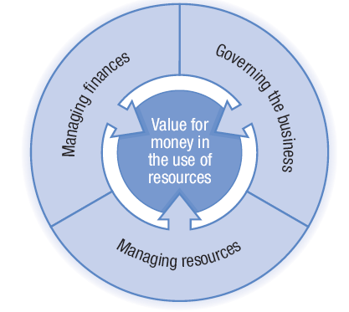

  - The Key Lines of Enquiry across the 3 themes are shown below in table 2 and will be assessed as in the past, based on a scale of 1 to 4 with four being the highest level of performance.

Table 2: Published Key lines of Enquiry 2008/09
Managing Finance
- Planning for financial health
- Understanding costs and achieving efficiencies
- Financial Reporting

Governing the Business
- Commissioning and procurement
- Use of information
- Good governance
- Risk management and internal control

Managing Resources
- Natural resources
- Strategic asset management
- Workforce

  - The Use of Resources assessment can provide the council with important evidence in support of any application it may make for a corporate assessment and any re-categorisation of their Comprehensive Performance Assessment (CPA) rating.

  - In 2009 the CPA has been replaced by the Comprehensive Area Assessment (CAA), which is intended as a wider assessment based more upon outputs and value for money than on processes. The CAA is area based and will look at partnership working across the area and link with the new Performance National Indicator Set and Local Area Agreement. The Use of Resources assessment forms part of the CAA from 2009 and will also feed into other performance assessment frameworks.

- UPDATE ON PROGRESS WITH 2009 ASSESSMENT.

  - On 16 January 2009 we attended a training event run by the Audit Commission at South Ribble BC. We found the session to be very informative and useful and importantly provided us with reassurance that the approach we are taking in producing our self assessment is appropriate.

  - Following discussions with our auditors we were conscious of the extremely tight timetable surrounding this year’s assessment and set in place procedures to commence preparation of our self assessment immediately. CMT agreed to set up a formal working group of appropriate staff from which to draw relevant knowledge to inform our overall CAA and to also aid our UOR for future years.

  - On 26 February 2009 we met with Georgia Jones (Audit Commission) who kindly agreed to carry out an initial review of our progress to date with our self assessment. At this meeting Georgia emphasised the need for a focus on our outcomes throughout the assessment.

  - We have agreed to submit our final self assessment on 31 March 2009 and for the Audit Commission to carry our their review work in April. This followed considerable thought and discussion on how best to avoid conflicting workloads during the closure of accounts process.

  - The Audit Commission will publish the first CAA reports in late November 2009, allowing findings to be taken into account in reviews of the LAA, and to inform setting priorities and budgets for 2010/11.

- CONCLUSION

  - The Use of Resources framework has changed substantially from the previous format which will is resulting in a substantial amount of work in producing the self assessment and gathering new evidence for the KLOEs.

  - With the shift from ‘processes’ to ‘outputs’ it is important to involve all departments to some degree in order to capture all of our successes and to ensure that they are shown within the KLOEs as evidence of our value for money. The creation of the formal working group will facilitate this process.

  - Whilst the KLOEs for Natural Resources and Strategic Asset Management will not be assessed in the coming year as part of Use of Resources, it is important that the council continue to strive to follow best practice wherever possible.

  - We are reporting progress to CMT each month and will endeavour to update members as and when necessary.

FINANCIAL SERVICES MANAGER
17 MARCH 2009
AA6-09JP/AC

