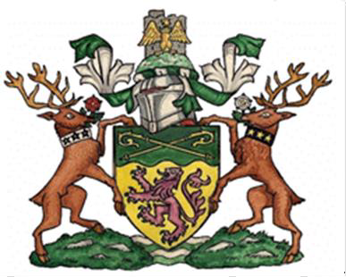
2023 Air Quality Annual Status Report (ASR)
In fulfilment of Part IV of the Environment Act 1995 Local Air Quality Management, as amended by the Environment Act 2021
Date: 19th September 2023

Information | Ribble Valley Borough Council Details
Local Authority Officer | Nicola Berry
Department | Environmental Health
Address | Ribble Valley Council, Council Offices, Church Walk, Clitheroe BB7 2RA
Telephone | 01200 425111
E-mail | Nicola.Berry@ribblevalley.gov.uk
Report Reference Number | ASR 2023
Date | 19th September 2023

Executive Summary: Air Quality in Our Area
This report fulfils the requirements of the Local Air Quality Management process as set out in Part IV of the Environment Act (1995), the Air Quality Strategy for England, Scotland, Wales and Northern Ireland 2007 and the relevant Policy and Technical Guidance documents. The LAQM process places an obligation on all local authorities to regularly review and assess air quality in their areas, and to determine whether the air quality objectives are likely to be achieved. Where exceedances are considered likely, the local authority must then declare an Air Quality Management Area (AQMA) and prepare an Air Quality Action Plan (AQAP) setting out the measures it intends to put in place in pursuit of the objectives.
Ribble Valley Council’s main pollutant of concern is Nitrogen Dioxide (NO₂); Ribble Valley monitors Nitrogen Dioxide through passive diffusion tubes measuring NO₂ in the air.
Ribble Valley has added additional NO₂ tubes in the reported monitoring year as of March 2022. The previous monitoring programme was deemed to be too Clitheroe centric. The diffusion tube network has been extended to incorporate the township of Longridge and the Village of Whalley. DT8 outside the Feildens Arms Mellor has been discontinued, and the monitoring in the Mellor area was moved to a nearby location which will see more passing traffic - DT10. Overall, a further 6 locations have been added meaning that the total number of monitoring locations at the end of 2022 is 14 tubes. Sites were chosen in Longridge as there has been significant residential development, both in the town and in the surrounding area. The road network outside of Longridge to the west has had changes in the nearby Preston area. The village of Whalley was selected for monitoring which is a busy village with much housing development and tourism.
The results for 2022 show no exceedances of the National Objective for the annual bias adjusted figures for NO₂; the highest and lowest site measurements in the Authority area being 28.1 µg/m³ and 9.1 µg/m³ respectively.
Levels of NO₂ over the last few years have been reducing, the monitoring period of 2022 has higher levels at DT1, DT2, DT5 and DT9 when compared to the 2021 levels. The three other locations DT3, DT4, DT6 have reduced values compared to 2021. Although the increases are not ideal, the levels of increase on each location are not over 1 µg/m³ on the annual bias adjusted mean. The increase could be down to more vehicle movements as we move out of the Covid pandemic and into the recovery phase. Ribble Valley is an area where tourism is significant and of key importance to the local economy and there are several large events which were suspended in 2021 but recontinued in 2022. This could have increased the levels in the locations reported. On a positive note, all levels are lower than the pre-pandemic year of 2019, suggesting that improvements to vehicles on the road such as more petrol cars over diesel models, more hybrid cars and the move to electric vehicles are reducing the levels in accordance with the National trend.
Figure A.1 shows the graph representation of the levels from 2018 to 2022 using the data from Table A.4.
Ribble Valley has one Air Quality Management Area, declared in 2010 for exceedance of NO₂. Within the reporting year the concentration of NO₂ is below the objective for the concentration of NO₂.
There have been no noteworthy sources of increasing levels of NO₂ in the Borough. The major source of the pollutant NO₂ in the Ribble Valley Borough Council area is from traffic.
The Officer responsible for air quality in Ribble Valley is in a local air quality group with their counterpart Officers from several Lancashire authorities, the purpose of the group is to keep updated on current developments in pollution control, share good practice, workshop air quality problems and liaise on cross boundary air pollution issues. The Lancashire group has responded to consultations at national level on guidelines for activities affecting air quality.
The Officer also maintains close working relations with the Environment Agency; Lancashire County Council, DEFRA, Planning, and consultancies to facilitate a coordinated approach to improve air quality.
Lancashire County Council are pursuing several strategies to improve air quality throughout the County, a summary of which is included in this report.

Air Quality in Ribble Valley Borough Council
Air pollution is associated with several adverse health impacts. It is recognised as a contributing factor in the onset of heart disease and cancer. Additionally, air pollution particularly affects the most vulnerable in society: children, the elderly, and those with existing heart and lung conditions. There is also often a strong correlation with equalities issues because areas with poor air quality are also often less affluent areas,.
The mortality burden of air pollution within the UK is equivalent to 29,000 to 43,000 deaths at typical ages, with a total estimated healthcare cost to the NHS and social care of £157 million in 2017.
The UK Health Security Agency Public Health Outcomes Framework collated by the Office for Health Inequalities and Disparities provides the best evidence on the impact of air pollution on Ribble Valley’s population, the website has a health protection indicator that considers the fraction of mortality in each area attributable to particulate air pollution. The 2021 results (the most recent published) revealed that the mortality rate for England was 5.5%. The value for Ribble Valley was lower than the national level at 4.3% and lower than the Northwest Region of 5.5% the lowest ranking of the Lancashire areas. The information demonstrates that particulate air pollution is an important public health issue for the Ribble Valley population. The results of the estimated background maps from the UK air website have been considered for both PM_{2.5} and PM₁₀ within the Ribble Valley area. No exceedance of the current air quality objective has occurred in Ribble Valley for both types of these particulates in 2022.
Currently Ribble Valley Borough Council monitors Nitrogen Dioxide (NO₂) as this is a local air quality issue, mainly associated with traffic; this is our primary monitoring focus.
Ribble Valley has added additional NO₂ tubes in the reported monitoring year as of March 2022. The previous monitoring programme was deemed to be too Clitheroe centric. The diffusion tube network has been extended to incorporate the township of Longridge and the Village of Whalley. DT8 outside the Feildens Arms Mellor has been discontinued, and the monitoring in the Mellor area was moved to a nearby location which will see more passing traffic - DT10. Overall, a further 6 locations have been added, meaning that the total number of monitoring locations at the end of 2022 is 14 tubes. Sites were chosen in Longridge as there has been significant residential development, both in the town and in the surrounding area. The road network outside of Longridge to the west has had changes in the nearby Preston area. The village of Whalley was selected for monitoring which is a busy village with much housing development and tourism.
Ribble Valley has one Air Quality Management Area [AQMA] within the borough, located in Clitheroe, this is known as Whalley Road Clitheroe Number 1.
The NO₂ results for 2022 show no exceedances of the National Objective for the annual bias adjusted figures throughout the area, the highest and lowest site measurements being 28.1 µg/m³ and 9.1 µg/m³ respectively.
It is important that work continues to maintain and improve the air quality within the Ribble Valley, given:
- The evidence on the harmful effects of both Particulate Matter and Nitrogen Dioxide.
- The Council’s Ambition 3 To help make people’s lives safer and healthier and Ambition 4 To protect and enhance the existing environmental quality of our area (Corporate Strategy 2019-2023).
- The Council’s duties under the Local Air Quality Management regime.
- The significant housing and business development within the area.
To that end, Ribble Valley Borough Council will continue to identify measures to improve and maintain the air quality within the Borough, including ensuring developments do not adversely affect or significantly contribute to pollutant levels.
There have been no new major roads or industrial processes constructed within the reporting year that will have a significant impact on air quality within the Borough.
The monitoring period of 2022 has higher levels at DT1, DT2, DT5 and DT9 when compared to the 2021 levels. The three other locations DT3, DT4, DT6 have reduced values compared to 2021. Although the increases are not ideal, the levels of increase on each location are not over 1 µg/m³ on the annual bias adjusted mean. The increase could be down to more vehicle movements as we move out of the Covid pandemic and into the recovery phase. Ribble Valley is an area where tourism is significant and of key importance to the local economy and there are several large events which were suspended in 2021 but recontinued in 2022. This could have increased the levels in the locations reported. On a positive note, all levels are lower than the pre-pandemic year of 2019, suggesting that improvements to vehicles on the road such as more petrol cars over diesel models, more hybrid cars and the move to electric vehicles are reducing the levels in accordance with the National trend.
Figure A.1 shows the graph representation of the levels from 2018 to 2022 using the data from Table A.4.
Ribble Valley has one Air Quality Management Area, declared in 2010 for exceedance of NO₂. Within the reporting year the concentration of NO₂ is below the objective for the concentration of NO₂.
There have been no noteworthy sources of increasing levels of NO₂ in the Borough. The major source of the pollutant NO₂ in the Ribble Valley Borough Council area is from traffic.
The Officer responsible for air quality in Ribble Valley is in a local air quality group with their counterpart Officers from several Lancashire authorities, the purpose of the group is to keep updated on current developments in pollution control, share good practice, workshop air quality problems and liaise on cross boundary air pollution issues. The Lancashire group has responded to consultations at national level on guidelines for activities affecting air quality.
The Officer also maintains close working relations with the Environment Agency; Lancashire County Council, DEFRA, Planning, and consultancies to facilitate a coordinated approach to improve air quality.
Lancashire County Council are pursuing several strategies to improve air quality throughout the County, a summary of which is included in this report.

Actions to Improve Air Quality
Whilst air quality has improved significantly in recent decades, there are some areas where local action is needed to protect people and the environment from the effects of air pollution.
The Environmental Improvement Plan sets out actions that will drive continued improvements to air quality and to meet the new national interim and long-term PM_{2.5} targets. The National Air Quality Strategy, due to be published in 2023, will provide more information on local authorities' responsibilities to work towards these new targets and reduce PM_{2.5} in their areas. The Road to Zero details the approach to reduce exhaust emissions from road transport through several mechanisms; this is extremely important given that the majority of Air Quality Management Areas (AQMAs) are designated due to elevated concentrations heavily influenced by transport emissions.
Key actions the Council will be looking at over the next year include:
- Continuing with the now extended diffusion tube monitoring programme, including those within the AQMA.
- Continue to consider air quality for all relevant planning applications.
- Explore the requirements of a detailed assessment and undertake such measures with a view to revoke the AQMA which has not exceeded levels since 2016.
- Encourage greater use of public transport and alternative forms of travel, including the provision of electric vehicle recharging points through the planning system.
- We will continue to carry out the inspections and enforcement of permitted premises within the Borough under the Environmental Permitting Regulations.
- Continue to work with partners in Public Health Lancashire, and across the Lancashire District authorities in the development and publication of the Lancashire Air Quality Documents.

Conclusions and Priorities
The results from the 2022 monitoring programme and review of the government data have identified no areas of likely exceedances of the national objective values for any of the pollutants of concern inside or outside of the declared AQMA.
Levels of NO₂ over the last few years have been reducing, the monitoring period of 2022 has higher levels at DT1, DT2, DT5 and DT9 when compared to the 2021 levels. The three other locations DT3, DT4, DT6 have reduced values compared to 2021. Although the increases are not ideal, the levels of increase on each location are not over 1 µg/m³ on the annual bias adjusted mean. The increase could be down to more vehicle movements as we move out of the Covid pandemic and into the recovery phase. Ribble Valley is an area where tourism is significant and of key importance to the local economy and there are several large events which were suspended in 2021 but recontinued in 2022. This could have increased the levels in the locations reported. On a positive note, all levels are lower than the pre-pandemic year of 2019, suggesting that improvements to vehicles on the road such as more petrol cars over diesel models, more hybrid cars and the move to electric vehicles are reducing the levels in accordance with the National trend.
All annual monitoring levels for 2022 are lower than the objective value of 40µg/m3. With the levels it is appropriate to revoke the AQMA. Ribble Valley Borough Council needs to undertake a detailed assessment of the AQMA with the view of revocation in mind, as there has been no exceedance of the objective since 2016. The Council need to produce an Air Quality Action Plan as required by the Borough having an AQMA.
The Council knows of no developments which should have an impact on air quality.

Local Engagement and How to get Involved
The public can get involved by helping to make informed choices about their method of transport. By choosing to make shorter journeys on foot or using cycling and public transport you can reduce your own emissions. Consider car sharing, getting a lift with others is a sociable way to save money and emissions, you can register on sites such as Lift share (https://liftshare.com/uk) to find others in your area.
Working from home reduces the need to travel into work and thus reduces emissions into town centres.
For longer journeys the bus or train can be a more economical and eco-friendly option.
When buying a new car think about fuel consumption and emissions data, the
Vehicle Certification Agency (VCA) can help with this.
http://www.dft.gov.uk/vca/fcb/index.asp. You could consider a lower emission vehicle, for example an electric car or hybrid. Even choosing a Petrol car over a Diesel car will save emissions and help to improve air quality. The Council aims to support electric car use by provision of charging points in the area.
When driving there are certain smarter driving techniques that you can use to reduce your fuel consumption. For further eco driving tips the AA is a helpful source
http://www.theaa.com/motoring_advice/fuels-and-environment/drive-smart.html
There is a renewables heat incentive for domestic properties to promote the use of renewable green deal schemes such as solar thermal panels, air source heat pumps, ground sources heat pumps and biomass boilers, as a means of heating homes these measures will improve air quality over a standard boiler system.
If you would like to get involved in the work being undertaken to tackle air pollution within Ribble Valley; or you would like more information on how you can help reduce your personal emissions then please contact the Environmental Health Department at Ribble Valley Borough Council via e-mail at environmental.health@ribblevalley.gov.uk
Please see Appendix F for ideas about how personal choices can help to improve air quality.

Local Responsibilities and Commitment
This ASR was prepared by the Environmental Health Department of Ribble Valley Borough Council with the support and agreement of the following officers and departments:
Mrs Nicola Berry – Environmental Health Officer
This ASR has been approved by:
Mr Andrew Dent Head of Environmental Health
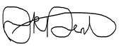

This ASR has not been signed off by a Director of Public Health.
If you have any comments on this ASR, please send them to Environmental Health at:
Ribble Valley Council, Council Offices, Church Walk, Clitheroe BB7 2RA
Telephone - 01200 425111
Email - environmental.health@ribblevalley.gov.uk

Table of Contents
Executive Summary: Air Quality in Our Area i
Air Quality in Ribble Valley Borough Council ii
Actions to Improve Air Quality v
Conclusions and Priorities vii
Local Engagement and How to get Involved vii
Local Responsibilities and Commitment viii
1 Local Air Quality Management 1
2 Actions to Improve Air Quality 2
2.1 Air Quality Management Areas 3
2.2 Progress and Impact of Measures to address Air Quality in Ribble Valley Borough Council 5
2.3 PM_{2.5} – Local Authority Approach to Reducing Emissions and/or Concentrations. 9
3 Air Quality Monitoring Data and Comparison with Air Quality Objectives and National Compliance 11
3.1 Summary of Monitoring Undertaken 11
3.1.1 Non-Automatic Monitoring Sites 11
3.2 Individual Pollutants 12
3.2.1 Nitrogen Dioxide (NO₂) 12
3.2.2 Particulate Matter (PM₁₀) 12
3.2.3 Particulate Matter (PM_{2.5}) 12
3.2.4 Sulphur Dioxide (SO₂) 12
Appendix A: Monitoring Results 13
Appendix B: Full Monthly Diffusion Tube Results for 2022 17
Appendix C: Supporting Technical Information / Air Quality Monitoring Data QA/QC 18
New or Changed Sources Identified Within Ribble Valley Borough Council During 2022 18
Additional Air Quality Works Undertaken by Ribble Valley Borough Council During 2022 18
QA/QC of Diffusion Tube Monitoring 18
Diffusion Tube Annualisation 18
Diffusion Tube Bias Adjustment Factors 19
NO₂ Fall-off with Distance from the Road 19
Appendix D: Map(s) of Monitoring Locations and AQMAs 20
Appendix E: Summary of Air Quality Objectives in England 34
Glossary of Terms 35
References 36

Figures
Figure A.1 – Trends in Annual Mean NO₂ Concentrations 16

Figure D.1 – Maps of Non-Automatic Monitoring Sites 20
Tables
Table 2.1 – Declared Air Quality Management Areas 4
Table 2.2 – Progress on Measures to Improve Air Quality 8

Table A.2 – Details of Non-Automatic Monitoring Sites 13
Table A.4 – Annual Mean NO₂ Monitoring Results: Non-Automatic Monitoring (µg/m³) 15
Table B.1 – NO₂ 2022 Diffusion Tube Results (µg/m³) 17

Table C.2 – Bias Adjustment Factors 19

Table E.1 – Air Quality Objectives in England 34

Local Air Quality Management
This report provides an overview of air quality in Ribble Valley Borough Council during 2022. It fulfils the requirements of Local Air Quality Management (LAQM) as set out in Part IV of the Environment Act (1995), as amended by the Environment Act (2021), and the relevant Policy and Technical Guidance documents.
The LAQM process places an obligation on all local authorities to regularly review and assess air quality in their areas, and to determine whether the air quality objectives are likely to be achieved. Where an exceedance is considered likely the local authority must declare an Air Quality Management Area (AQMA) and prepare an Air Quality Action Plan (AQAP) setting out the measures it intends to put in place to achieve and maintain the objectives and the dates by which each measure will be carried out. This Annual Status Report (ASR) is an annual requirement showing the strategies employed by Ribble Valley Borough Council to improve air quality and any progress that has been made.
The statutory air quality objectives applicable to LAQM in England are presented in Table E.1.

Actions to Improve Air Quality
Whilst air quality has improved significantly in recent decades and will continue to improve due to national policy decisions, there are some areas where local action is needed to improve air quality further.
The 2019 Clean Air Strategy sets out the case for action, with goals even more ambitious than EU requirements to reduce exposure to harmful pollutants. The Road to Zero sets out the approach to reduce exhaust emissions from road transport through several mechanisms; this is extremely important given that the majority of Air Quality Management Areas (AQMAs) are designated due to elevated concentrations heavily influenced by transport emissions.
Key actions the Council will be looking at over the next year include:
- Continuing with the now extended diffusion tube monitoring programme, including those within the AQMA.
- Continue to consider air quality for all relevant planning applications.
- Explore the requirements of a detailed assessment and undertake such measures with a view to revoke the AQMA which has not exceeded levels since 2016.
- Encourage greater use of public transport and alternative forms of travel, including the provision of electric vehicle recharging points through the planning system.
- We will continue to carry out the inspections and enforcement of permitted premises within the Borough under the Environmental Permitting Regulations.
- Continue to work with partners in Public Health Lancashire, and across the Lancashire District authorities in the development and publication of the Lancashire Air Quality Documents.
- Undertake a detailed assessment of the AQMA with revocation in mind.
- The Council need to produce an Air Quality Action Plan as required by the Borough having an AQMA.
Other actions the Council is taking, and the Lancashire County Council is reported in Table 2.2

Air Quality Management Areas
Air Quality Management Areas (AQMAs) are declared when there is an exceedance or likely exceedance of an air quality objective. After declaration, the authority should prepare an Air Quality Action Plan (AQAP) within 18 months. The AQAP should specify how air quality targets will be achieved and maintained and provide dates by which measures will be carried out.
A summary of AQMAs declared by Ribble Valley Borough Council can be found in Table 2.1. The table presents a description of the one AQMA that is currently designated within Ribble Valley Borough Council. Appendix D: Map(s) of Monitoring Locations and AQMAs provides maps of the AQMA and also the air quality monitoring locations in relation to the AQMA. The air quality objectives pertinent to the current AQMA designation are as follows:
- NO₂ annual mean.
Ribble Valley Borough Council propose to revoke Whalley Road Clitheroe Number 1 as there have been no annual exceedances since 2016.

Table 2.1 – Declared Air Quality Management Areas
AQMA Name | Date of Declaration | Pollutants and Air Quality Objectives | One Line Description | Is air quality in the AQMA influenced by roads controlled by Highways England? | Level of Exceedance: Declaration | Level of Exceedance: Current Year | Number of Years Compliant with Air Quality Objective | Name and Date of AQAP Publication | Web Link to AQAP
Whalley Road Clitheroe Number 1 | 31st May2010 | NO2 Annual Mean | An area encompassing a number of residential properties at the junction of Whalley Road and Greenacre Street. | NO | 45 | Highest level 28.1 No exceedance | 5 years | N/A | N/A
☒ Ribble Valley Borough Council confirm the information on UK-Air regarding their AQMA is up to date.
☐ Ribble Valley Borough Council confirm that all current AQAPs have been submitted to Defra.

Progress and Impact of Measures to address Air Quality in Ribble Valley Borough Council
Defra’s appraisal of last year’s ASR concluded as follows:
Commentary
The report is well structured, detailed, and provides the information specified in the Guidance. The following comments are designed to help inform future reports:
- Trends have been presented with a robust comparison to the Air Quality Objectives.
- QA/QC procedures are robust, with sufficient supporting evidence provided.
- Positive work has been with partners in Public Health Lancashire and across the Lancashire District authorities, and this should continue.
- Any erroneous data should be removed, e.g., Sep 2020 reports a NO₂ diffusion tube concentration of 0 µg/m³, which does appear unusual for a diffusion tube concentration.
- An AQAP should be published, and this is a requirement for all AQMAs.
- The decision is supported to revoke the AQMA, and the Council should proceed with completing a detailed assessment and we expect an update on this in the next ASR.
- A map of all of the diffusion tubes on a single figure may be helpful for context.
Considering the appraisal from DEFRA the response to comments 4 - 7 are included below:
4. The NO2 diffusion tube reading for September 2020 was reported as 0.0. This was an error. The tube should have been reported as N/A (not available). Looking at the raw data results, the tube was missing from the analysis. This means that the annual bias adjusted level for DT4 was reported at 19.5 µg/m³ but should have been 21.4 µg/m³. This figure has been derived using the same adjustment bias as in the previous report, but the total annual levels have been averaged over an 11-month monitoring period rather than the 12-month average. Data capture was 91.7% instead of the 100% reported. The result is presented in Table A.4, bold font has been used to denote the correction.
5. AQAP- Needs to be published.
6. Due to the short reporting period between last year’s Jan 2022 and this year’s report, September 2022. Coupled with staffing shortages in the Department the Council has not had the opportunity to revoke the AQMA. Advise need to be sought on the requirements for undertaking a detailed assessment from the results the revocation can occur.
7. In addition to the individual tube locations, a map of the Borough has been provided showing the location of the position of all the Tubes.
Ribble Valley Borough Council has taken forward several direct measures during the current reporting year of 2022 in pursuit of improving local air quality. Details of all measures completed, in progress or planned are set out in Table 2.2. 11 measures are included within Table 2.2, with the type of measure and the progress Ribble Valley Borough Council have made during the reporting year of 2022 presented. Where there have been, or continue to be, barriers restricting the implementation of the measure, these are also presented within Table 2.2.
Ribble Valley Borough Council expects the following measures to be completed over the course of the next reporting year:
- To ensure all new developments have some form of electric vehicle recharging capability.
- Ensure all new developments have adequate cycle storage, especially commercial/industrial developments.
- Encourage the use of alternative means of travel to the internal combustion engine car through the provision of travel plans for new developments and the promotion of car sharing schemes, public transport and cycling.
- Progress the implementation of electric vehicle recharge points on Council owned car parks.
- Continue with the extended NO₂ monitoring programme.
Ribble Valley Borough Council anticipates that the measures stated above and in Table 2.2 will achieve compliance in our AQMA, Whalley Road Clitheroe Number 1.
Ribble Valley Borough Council expects the following measures to be completed over the course of the next reporting year:
Establish measures for detailed assessment for revoking the AQMA.

Ribble Valley Borough Council worked to implement these measures in partnership with the following stakeholders during 2022:
- Neighbouring local authorities
- Lancashire Highways
- Lancashire County Council Public Health
- Environment Agency
- DEFRA
- Planning
The principal challenges and barriers to implementation that Ribble Valley Borough Council anticipates facing are lack of resources both within the Local Authority and partner organisations.
Progress on the following measures has been slower than expected due to:
- Short time between report 2022 ASR and 2023 ASR
- Lack of staff in the Department
Ribble Valley Borough Council anticipates that the measures stated above and in Table 2.2 will achieve compliance in Whalley Road Clitheroe Number 1.

Table 2.2 – Progress on Measures to Improve Air Quality
Measure No. | Measure | Category | Classification | Year Measure Introduced in AQAP | Estimated / Actual Completion Date | Organisations Involved | Funding Source | Defra AQ Grant Funding | Funding Status | Estimated Cost of Measure | Measure Status | Reduction in Pollutant / Emission from Measure | Key Performance Indicator | Progress to Date | Comments / Barriers to Implementation
1 | Require EVR points on all appropriate planning applications | Promoting Travel Alternatives | Other | 2016 | 2032 | Local Authority Environmental Health, Local Authority Planning Dept. Developers | Developers & highway infrastructure funding | YES | Partially Funded | £100k - £500k | Implementation | N/K | N/A | Ongoing | Lengthy Timescale
2 | Raise awareness with Members, and public | Public Information | Via the Internet | 2017 | 2032 | Local Authority Environmental Health Department. | Local Authority | NO | Not Funded | < £10k | Implementation | N/K | N/K | Implementation on-going | Funding
3 | Require cycle storage on all appropriate planning applications | Promoting Travel Alternatives | Other | 2016 | 2032 | Local Authority Environmental Health, Local Authority Planning Dept. Developers | Developers | NO | Not Funded | < £10k | Implementation | Reduced vehicle emissions | N/K | Implementation on-going | Financial
4 | Develop Lancashire wide Planning Guidance on Air Quality and Implement | Policy Guidance and Development Control | Regional Groups Co-ordinating programmes to develop Area wide Strategies to reduce emissions and improve air quality | 2016 | 2032 | Policy Guidance and Environmental Health | Local Authority | NO | Not Funded | < £10k | Implementation | Improved Air Quality | N/K | Implementation on-going | Local Planning Department, government policy on Planning
5 | Travel initiative for schools | Other | Other | 2020 | 2022 | Lancashire County Council. | Lancashire County Council | NO | Not Funded | < £10k | Implementation | Reduced vehicle emissions | N/K | Implementation on-going | Lengthy Timescale
6 | Encouraging the use of sustainable forms of travel | Promoting Travel Alternatives | Promotion of cycling | 2022 | 2028 | Lancashire County Council. | Lancashire County Council | NO | Not Funded |  | Implementation | Reduced AQ Emissions | N/K | Implementation on-going | Lengthy Timescale
7 | Supporting the transition to Low emission vehicles | Promoting Low Emission Transport | Other | 2022 | 2032 | Lancashire County Council. | Lancashire County Council | NO | Funded | £1 million - £10 million | Implementation | Reduced AQ emissions | N/K | Implementation on-going | Trial period with new technology
8 | Creating cleaner healthier road networks | Transport Planning and Infrastructure | Public transport improvements-interchanges stations and services | 2022 | 2022 | Lancashire County Council. | Lancashire County Council | NO | Not Funded |  | Planning | Reduced AQ Emissions | N/K | Planning | Lengthy Timescale
9 | Embedding Air Quality into Policy | Policy Guidance and Development Control | Air Quality Planning and Policy Guidance | 2022 | 2022 | Lancashire County Council. | Lancashire County Council | NO | Not Funded |  | Planning | Reduced AQ Emissions | N/K | Planning | Lengthy Timescale
10 | Raising Awareness and increasing engagement | Public Information | Via the Internet | 2022 | 2022 | Lancashire County Council. | Lancashire County Council | NO | Not Funded |  | Implementation | Reduced AQ Emissions | N/K | Implementation on-going | Public Awareness of site
11 | Increase monitoring points for NO2 in LA | Public Information | Other | 2022 | 2032 | Local Authority Environmental Health | Local Authority Environmental Health | NO | Not Funded | < £10k | Planning | Reduced AQ Emissions | N/K | Implementation on-going | Staff resources

PM_{2.5} – Local Authority Approach to Reducing Emissions and/or Concentrations.
As detailed in Policy Guidance LAQM.PG22 (Chapter 8), local authorities are expected to work towards reducing emissions and/or concentrations of PM_{2.5} (particulate matter with an aerodynamic diameter of 2.5µm or less). There is clear evidence that PM_{2.5} has a significant impact on human health, including premature mortality, allergic reactions, and cardiovascular diseases.
Ribble Valley Borough Council is taking the following measures to address PM_{2.5}:
- The inclusion of PM2.5 assessment within Air Quality Assessments carried out through the planning process.
- Encouraging the use of alternative travel options e.g., cycling, walking, and use of public transport.
- Provision of Electric Vehicle Recharging points on appropriate new developments.

- The provision of EVR points on Council car parks: 10 bays capable of 11kW at the Chester Avenue long-stay car park and 4 bays capable of 22kW at the Railway View Avenue short-stay car park. These are in addition to the charging points provided by Lancashire CC in York Street and the points for customer use in the Tesco car park.
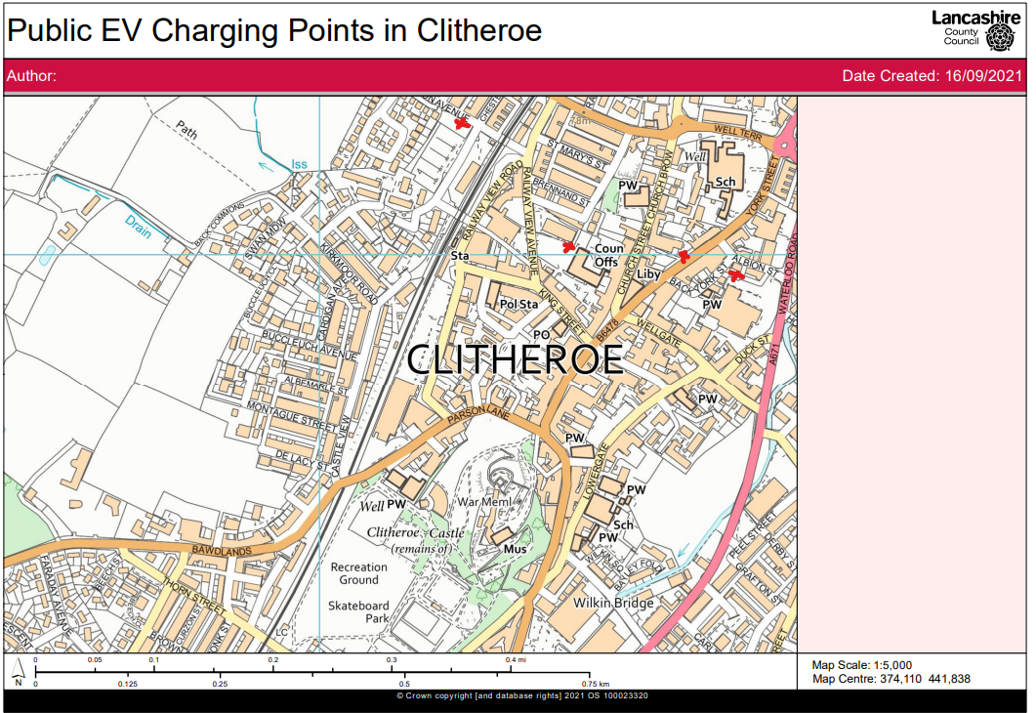
- Raise awareness of the harmful effects of PM2.5 using the Public Health Indicators which demonstrate that Ribble Valley suffers from an adult mortality attributed to particulate matter of 4.3%.

Air Quality Monitoring Data and Comparison with Air Quality Objectives and National Compliance
This section sets out the monitoring undertaken within 2022 by Ribble Valley Borough Council and how it compares with the relevant air quality objectives. In addition, monitoring results are presented for a five-year period between 2018 and 2022 to allow monitoring trends to be identified and discussed.
A review of the area has been undertaken to assess any changes that have occurred over the last 12 months and the potential for these to impact either negatively or positively on-air quality.
Significant residential development has been granted planning permission in some areas of the borough. Air quality reports have been prepared for most of these larger developments with most indicating a negligible impact. Monitoring of the Borough using diffusion tubes was increased during 2022 and the results are detailed below.
There have been no major road improvements or new roads or significant changes in traffic flow over the last year, with no significant changes to the railway network throughout the borough. There are no bus depots or significant ports within the borough. The airport at BAE systems Samlesbury is no longer used due to significant construction.
No new industrial sources, including biomass plants have been identified which are likely to make a significant contribution to pollutant emissions.

Summary of Monitoring Undertaken

Non-Automatic Monitoring Sites
Ribble Valley Borough Council undertook non- automatic (i.e., passive) monitoring of NO₂ at 14 sites during 2022. Table A.2 in Appendix A presents the details of the non-automatic sites.
Maps showing the location of the monitoring sites are provided in Appendix D. Further details on Quality Assurance/Quality Control (QA/QC) for the diffusion tubes, including bias adjustments and any other adjustments applied (e.g., annualisation and/or distance correction), are included in Appendix C.

Individual Pollutants
The air quality monitoring results presented in this section are, where relevant, adjusted for bias, annualisation (where the annual mean data capture is below 75% and greater than 25%), and distance correction. Further details on adjustments are provided in Appendix C.

Nitrogen Dioxide (NO₂)
Table A.3 and Table A.4 in Appendix A compare the ratified and adjusted monitored NO₂ annual mean concentrations for the past five years with the air quality objective of 40µg/m³. Note that the concentration data presented represents the concentration at the location of the monitoring site, following the application of bias adjustment and annualisation, as required (i.e., the values are exclusive of any consideration to fall-off with distance adjustment).
For diffusion tubes, the full 2022 dataset of monthly mean values is provided in Appendix B. Note that the concentration data presented in Table B.1 includes distance corrected values, only where relevant.

Particulate Matter (PM₁₀)
Ribble Valley Borough Council does not monitor PM₁₀ levels. However. a check of the Defra background maps indicates no likely exceedances of the objective levels for PM10.

Particulate Matter (PM_{2.5})
Ribble Valley Borough Council does not monitor PM_{2.5} levels. However, an evaluation of the Defra background maps has been undertaken when writing this report for PM_{2.5} levels.

Sulphur Dioxide (SO₂)
Ribble Valley Borough Council does not monitor SO₂ levels.

Appendix A: Monitoring Results

Table A.2 – Details of Non-Automatic Monitoring Sites
Diffusion Tube ID | Site Name | Site Type | X OS Grid Ref (Easting) | Y OS Grid Ref (Northing) | Pollutants Monitored | In AQMA? Which AQMA? | Distance to Relevant Exposure (m) ⁽¹⁾ | Distance to kerb of nearest road (m) ⁽²⁾ | Tube Co-located with a Continuous Analyser? | Tube Height (m)
DT1 | 31 Bolland Prospect | Urban Background | 374789 | 441513 | NO₂ | No | 0 | 6.8 | No | 2.0
DT2 | Royal British Legion 1 | Roadside | 374234 | 441291 | NO₂ | Yes AQMA 1 | 0 | 1.8 | No | 2.0
DT3 | Royal British Legion 2 | Roadside | 374234 | 441291 | NO₂ | Yes AQMA 1 | 0 | 1.8 | No | 2.0
DT4 | Greenacre Street | Roadside | 374222 | 441315 | NO₂ | Yes AQMA 1 | 0 | 1.5 | No | 2.0
DT5 | 49 Whalley Road | Roadside | 374219 | 441256 | NO₂ | Yes AQMA 1 | 0 | 1.6 | No | 2.0
DT6 | 85 Whalley Road | Roadside | 374175 | 441153 | NO₂ | No | 0 | 1.6 | No | 2.0
DT7 | Entrance at John Wall Court | Roadside | 373910 | 441501 | NO₂ | No | 10 | 4.1 | No | 2.0
DT8 | Feildens Arms | Roadside | 364027 | 431179 | NO₂ | No | 13.6 | 1.0 | No | 2.0
DT9 | 7/9 Whalley Road Read | Roadside | 376878 | 434509 | NO₂ | No | 0 | 2.3 | No | 2.0
DT10 | Mellor Brook | Roadside | 363907 | 431271 | NO₂ | No | 15.1 | 2.1 | No | 2.0
DT11 | 1 Derby Road Longridge | Roadside | 360165 | 437576 | NO₂ | No | 0 | 1.5 | No | 2.0
DT12 | 1 Preston Road Longridge | Roadside | 360109 | 437110 | NO₂ | No | 0 | 2.5 | No | 2.0
DT13 | 22 Market Place Longridge | Roadside | 360627 | 437217 | NO₂ | No | 0.7 | 2.7 | No | 2.0
DT14 | 2 Clitheroe Road Whalley | Roadside | 373376 | 436455 | NO₂ | No | 13.5 | 3.6 | No | 2.0
DT15 | 1-3 Accrington Road Whalley | Roadside | 373353 | 436158 | NO₂ | No | 0 | 1.6 | No | 2.0
Notes:
(1) 0m if the monitoring site is at a location of exposure (e.g., installed on the façade of a residential property).
(2) N/A if not applicable.

Table A.4 – Annual Mean NO₂ Monitoring Results: Non-Automatic Monitoring (µg/m³)
Diffusion Tube ID | X OS Grid Ref (Easting) | Y OS Grid Ref (Northing) | Site Type | Valid Data Capture for Monitoring Period (%) ⁽¹⁾ | Valid Data Capture 2022 (%) ⁽²⁾ | 2018 | 2019 | 2020 | 2021 | 2022
DT1 | 374789 | 441513 | Urban Background | 100.0 | 100.0 | - | 10.0 | 9.1 | 8.5 | 9.1
DT2 | 374234 | 441291 | Roadside | 83.3 | 83.3 | 37.3 | 33.6 | 25.9 | 27.6 | 28.1
DT3 | 374234 | 441291 | Roadside | 100.0 | 100.0 | 37.0 | 34.5 | 26.6 | 28.1 | 26.2
DT4 | 374222 | 441315 | Roadside | 100.0 | 100.0 | 26.3 | 25 | 18.8 | 21.2 | 21.1
DT5 | 374219 | 441256 | Roadside | 100.0 | 100.0 | 32.2 | 32.8 | 25.5 | 26.7 | 27.1
DT6 | 374175 | 441153 | Roadside | 100.0 | 100.0 | 27.7 | 26.5 | 21.4 | 22.5 | 21.9
DT7 | 373910 | 441501 | Roadside | 100.0 | 100.0 | - | 16.0 | 13.9 | 15.3 | 14.9
DT8 | 364027 | 431179 | Roadside | 8.3 | 8.3 | 18.2 | 16.6 | 13.4 | 13.7 | N/A
DT9 | 376878 | 434509 | Roadside | 100.0 | 100.0 | - | - | - | 22.5 | 23.6
DT10 | 363907 | 431271 | Roadside | 91.7 | 91.7 | - | - | - | - | 10.9
DT11 | 360165 | 437576 | Roadside | 75.0 | 75.0 | - | - | - | - | 20.3
DT12 | 360109 | 437110 | Roadside | 83.3 | 83.3 | - | - | - | - | 23.1
DT13 | 360627 | 437217 | Roadside | 83.3 | 83.3 | - | - | - | - | 21.2
DT14 | 373376 | 436455 | Roadside | 83.3 | 83.3 | - | - | - | - | 19.9
DT15 | 373353 | 436158 | Roadside | 75.0 | 75.0 | - | - | - | - | 23.9
☐ Annualisation has been conducted where data capture is <75% and >25% in line with LAQM.TG22.
☒ Diffusion tube data has been bias adjusted at a value of 0.82 as per 6/23.
☒ Reported concentrations are those at the location of the monitoring site (bias adjusted and annualised, as required), i.e., prior to any fall-off with distance correction.
Notes:
The annual mean concentrations are presented as µg/m³.
Exceedances of the NO₂ annual mean objective of 40µg/m³ are shown in bold.
NO₂ annual means exceeding 60µg/m³, indicating a potential exceedance of the NO₂ 1-hour mean objective are shown in bold and underlined.

Means for diffusion tubes have been corrected for bias. All means have been “annualised” as per LAQM.TG22 if valid data capture for the full calendar year is less than 75%. See Appendix C for details.
Concentrations are those at the location of monitoring and not those following any fall-off with distance adjustment.
(1) Data capture for the monitoring period, in cases where monitoring was only carried out for part of the year.
(2) Data capture for the full calendar year (e.g., if monitoring was carried out for 6 months, the maximum data capture for the full calendar year is 50%).

Figure A.1 – Trends in Annual Mean NO₂ Concentrations

Appendix B: Full Monthly Diffusion Tube Results for 2022
Table B.1 – NO₂ 2022 Diffusion Tube Results (µg/m³)
DT ID | X OS Grid Ref (Easting) | Y OS Grid Ref (Northing) | Jan | Feb | Mar | Apr | May | Jun | Jul | Aug | Sep | Oct | Nov | Dec | Annual Mean: Raw Data | Annual Mean: Annualised and Bias Adjusted  0.82 | Annual Mean: Distance Corrected to Nearest Exposure | Comment
DT1 | 374789 | 441513 | 16.6 | 10.0 | 16.4 | 9.0 | 6.8 | 6.1 | 6.8 | 7.0 | 8.2 | 11.3 | 14.8 | 19.9 | 11.1 | 9.1 | N/A
DT2 | 374234 | 441291 | 41.0 | 28.2 | 40.8 | 38.6 | 27.9 | 26.8 | 25.0 | 28.7 | N/A | N/A | 42.2 | 43.6 | 34.3 | 28.1 | N/A
DT3 | 374234 | 441291 | 33.8 | 22.9 | 41.8 | 35.8 | 23.6 | 25.8 | 26.0 | 34.2 | 31.7 | 30.7 | 37.1 | 39.3 | 31.9 | 26.2 | N/A
DT4 | 374222 | 441315 | 31.0 | 21.0 | 29.8 | 24.9 | 21.2 | 19.3 | 18.2 | 21.5 | 25.4 | 27.5 | 31.0 | 37.2 | 25.7 | 21.1 | N/A
DT5 | 374219 | 441256 | 40.3 | 28.5 | 37.6 | 30.9 | 27.1 | 26.9 | 25.2 | 28.4 | 35.4 | 35.1 | 36.6 | 44.4 | 33.0 | 27.1 | N/A
DT6 | 374175 | 441153 | 27.8 | 23.8 | 32.6 | 27.0 | 21.2 | 20.7 | 19.5 | 24.0 | 24.6 | 30.6 | 36.3 | 32.3 | 26.7 | 21.9 | N/A
DT7 | 373910 | 441501 | 26.9 | 15.1 | 19.1 | 15.1 | 14.0 | 13.2 | 13.0 | 13.0 | 16.8 | 17.8 | 24.7 | 29.2 | 18.2 | 14.9 | N/A
DT8 | 364027 | 431179 | 27.2 | N/A | N/A | N/A | N/A | N/A | N/A | N/A | N/A | N/A | N/A | N/A | N/A | N/A | N/A | DT8 Discontinued February 2022
DT9 | 376878 | 434509 | 42.8 | 27.7 | 23.4 | 24.9 | 28.6 | 22.4 | 22.2 | 24.1 | 26.4 | 32.1 | 32.8 | 38.7 | 28.8 | 23.6 | N/A
DT10 | 363907 | 431271 | N/A | 17.2 | 19.1 | 16.6 | 11.5 | 10.3 | 12.7 | 12.8 | 12.9 | 12.8 | 16.6 | 17.4 | 13.3 | 10.9 | N/A | New
DT11 | 360165 | 437576 | N/A | N/A | 27.2 | 17.9 | 19.6 | 21.0 | 19.9 | 21.7 | N/A | 26.2 | 35.5 | 33.5 | 24.7 | 20.3 | N/A | New
DT12 | 360109 | 437110 | N/A | N/A | 33.3 | 27.0 | 24.2 | 20.8 | 20.7 | 24.2 | 25.5 | 31.5 | 39.9 | 34.9 | 28.2 | 23.1 | N/A | New
DT13 | 360627 | 437217 | N/A | N/A | 26.0 | 22.0 | 25.6 | 21.8 | 23.6 | 22.7 | 23.1 | 23.7 | 34.9 | 34.9 | 25.8 | 21.2 | N/A | New
DT14 | 373376 | 436455 | N/A | N/A | 26.7 | 24.2 | 21.3 | 19.6 | 17.4 | 21.3 | 23.0 | 25.3 | 28.6 | 35.9 | 24.3 | 19.9 | N/A | New
DT15 | 373353 | 436158 | N/A | N/A | 32.8 | 30.6 | N/A | 26.0 | 27.5 | 29.3 | 30.9 | 23.4 | 30.8 | 31.2 | 29.2 | 23.9 | N/A | New
☒ All erroneous data has been removed from the NO₂ diffusion tube dataset presented in Table B.1.
☒ Annualisation has been conducted where data capture is <75% and >25% in line with LAQM.TG22.
☐ Local bias adjustment factor used.
☒ National bias adjustment factor used from 6/23.
☐ Where applicable, data has been distance corrected for relevant exposure in the final column.
☒ Ribble Valley Borough Council confirm that all 2022 diffusion tube data has been uploaded to the Diffusion Tube Data Entry System.
Notes:
Exceedances of the NO₂ annual mean objective of 40µg/m³ are shown in bold.
NO₂ annual means exceeding 60µg/m³, indicating a potential exceedance of the NO₂ 1-hour mean objective are shown in bold and underlined.
See Appendix C for details on bias adjustment and annualisation.

Appendix C: Supporting Technical Information / Air Quality Monitoring Data QA/QC

New or Changed Sources Identified Within Ribble Valley Borough Council During 2022
Ribble Valley Borough Council has not identified any new sources relating to air quality within the reporting year of 2022.

Additional Air Quality Works Undertaken by Ribble Valley Borough Council During 2022
Ribble Valley Borough Council has increased the monitoring programme within the reporting year of 2022.

QA/QC of Diffusion Tube Monitoring
50% TEA in acetone NO₂ passive diffusion tubes are obtained from Gradko Environmental, St Martins House, 77 Wales Street, Winchester, and Hampshire, SO23 0RH with no change in supplier throughout the monitoring period.
Nitrogen Dioxide diffusion tubes are exposed monthly in accordance with the annual calendar of exposure periods provided by Defra.
A national bias adjustment factor was applied to the annual mean for the diffusion tubes results. The bias used was from the National Diffusion Tubes spreadsheet version number 06/23 an adjustment factor of 0.82 was applied to the 2022 data.

Diffusion Tube Annualisation
All diffusion tube monitoring locations within Ribble Valley Borough Council recorded data capture of 75% except for one site which is discontinued and not included in the reported levels. Therefore, it was not required to annualise any monitoring data. In addition, any sites with a data capture below 25% such as the discontinued site do not require annualisation.

Diffusion Tube Bias Adjustment Factors
The diffusion tube data presented within the 2022 ASR have been corrected for bias using an adjustment factor. Bias represents the overall tendency of the diffusion tubes to under or over-read relative to the reference chemiluminescence analyser. LAQM.TG22 provides guidance regarding the application of a bias adjustment factor to correct diffusion tube monitoring. Triplicate co-location studies can be used to determine a local bias factor based on the comparison of diffusion tube results with data taken from NO_{x}/NO₂ continuous analysers. Alternatively, the national database of diffusion tube co-location surveys provides bias factors for the relevant laboratory and preparation method.
Ribble Valley Borough Council have applied a national bias adjustment factor of 0.82 to the 2022 monitoring data. A summary of bias adjustment factors used by Ribble Valley Borough Council over the past five years is presented in Table C.2.
Table C.2 – Bias Adjustment Factors
Monitoring Year | Local or National | If National, Version of National Spreadsheet | Adjustment Factor
2022 | National | 06/23 | 0.82
2021 | National | 09/22 | 0.82
2020 | National | 09/22 | 0.84
2019 | National | 09/22 | 0.89
2018 | National | 03/18 | 0.97

NO₂ Fall-off with Distance from the Road
Wherever possible, monitoring locations are representative of exposure. However, where this is not possible, the NO₂ concentration at the nearest location relevant for exposure has been estimated using the Diffusion Tube Data Processing Tool/NO₂ fall-off with distance calculator available on the LAQM Support website. Where appropriate, non-automatic annual mean NO₂ concentrations corrected for distance are presented in Table B.1.
No diffusion tube NO₂ monitoring locations within Ribble Valley Borough Council required distance correction during 2022.

Appendix D: Map(s) of Monitoring Locations and AQMAs
Figure D.1 – Maps of Non-Automatic Monitoring Sites
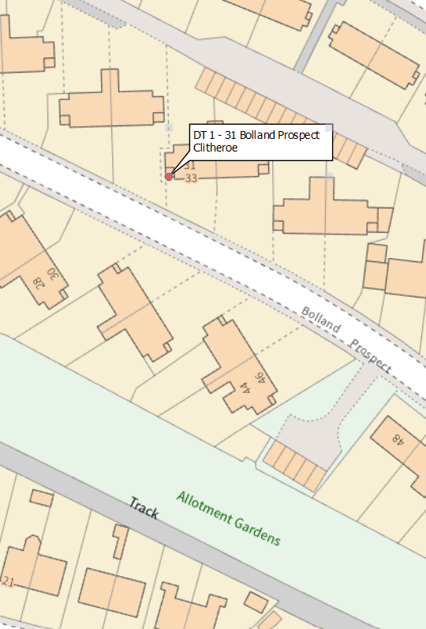
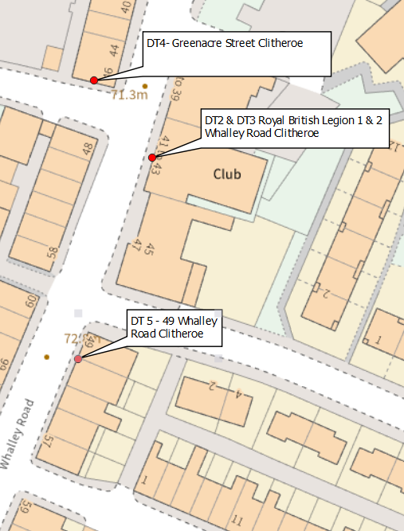
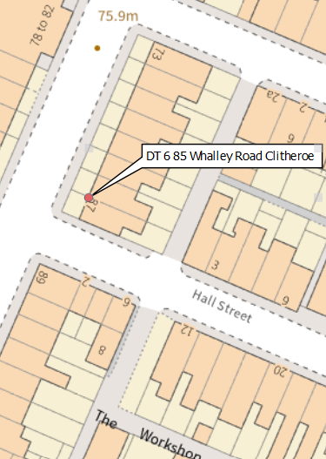
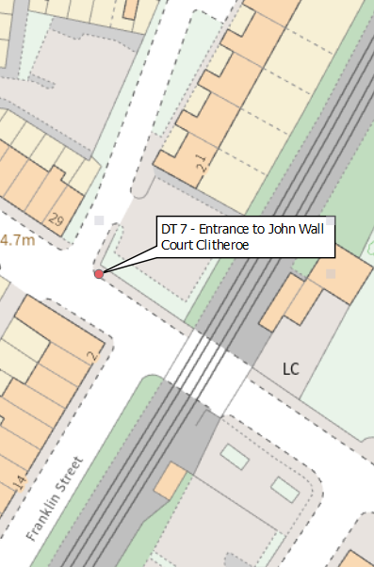
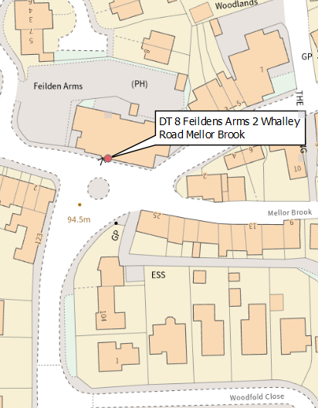
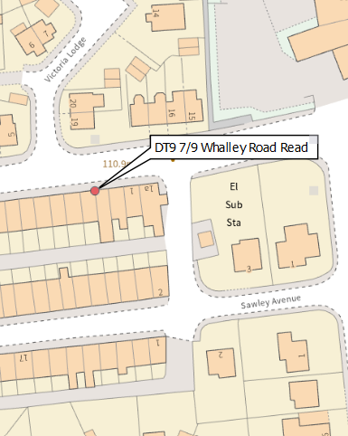
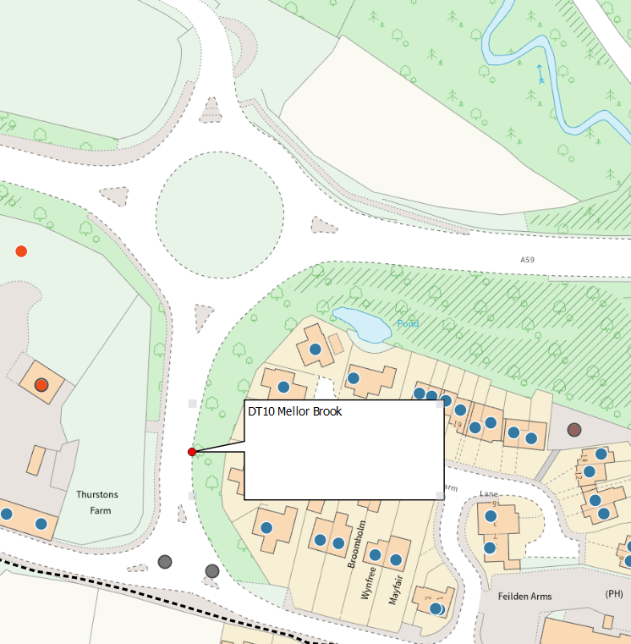

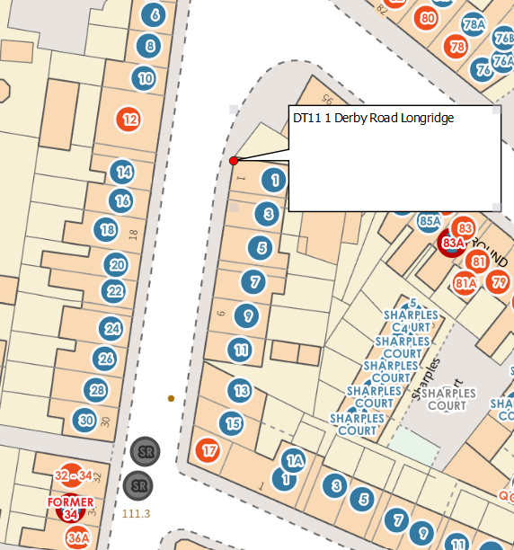

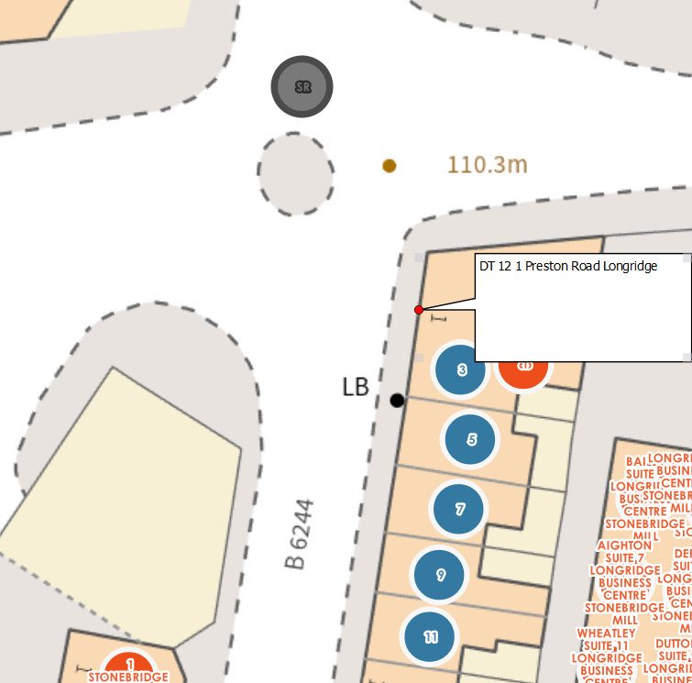
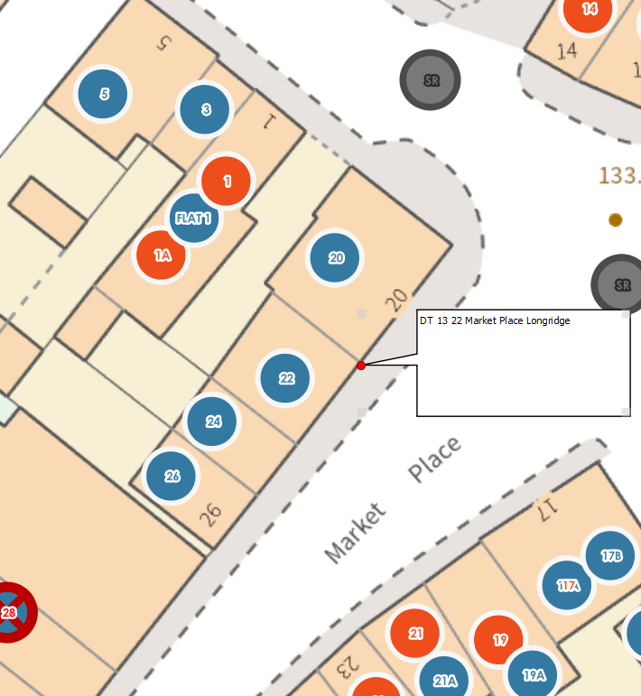
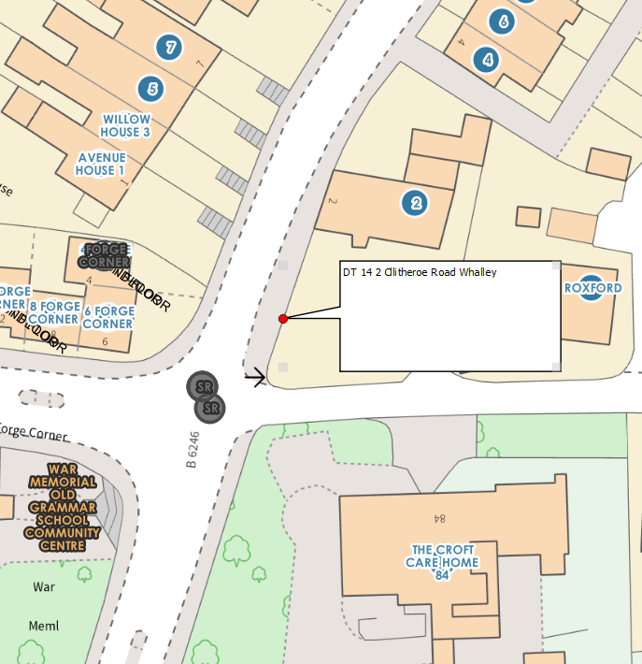
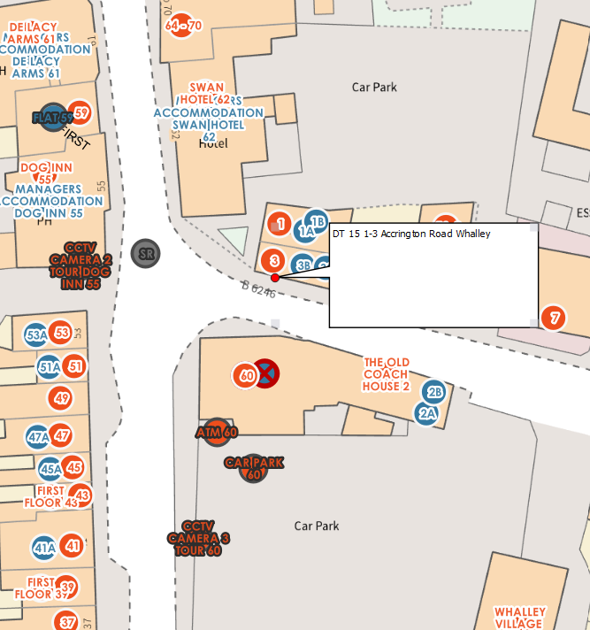

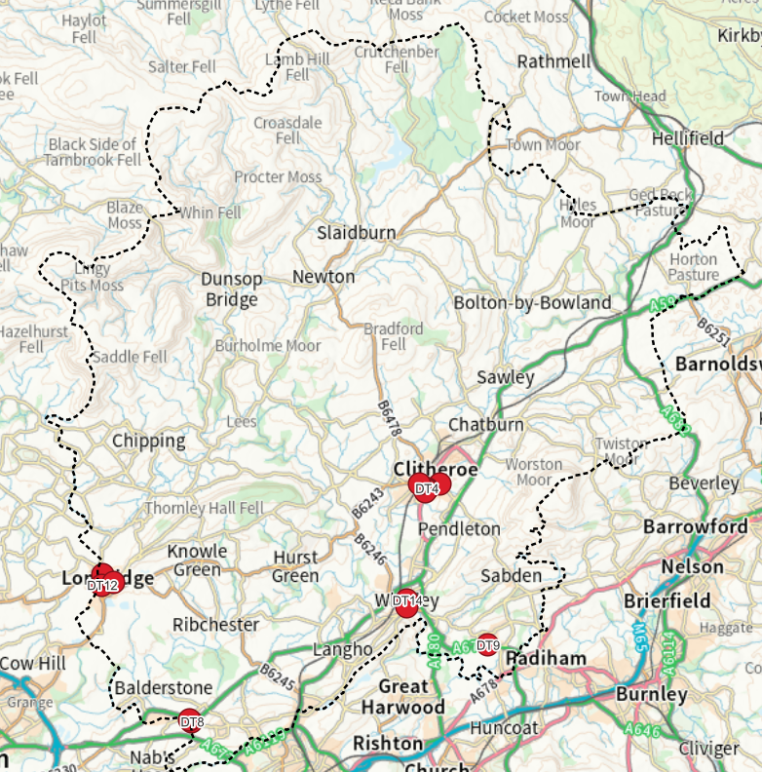

Figure D.2- Map of AQMA
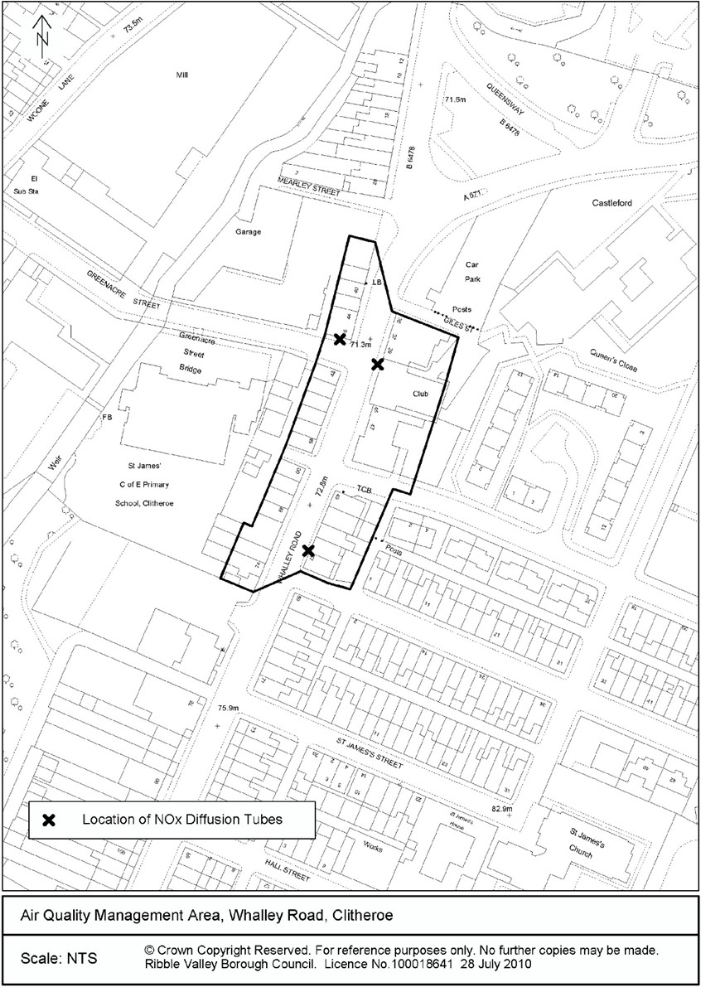

Appendix E: Summary of Air Quality Objectives in England
Table E.1 – Air Quality Objectives in England
Pollutant | Air Quality Objective: Concentration | Air Quality Objective: Measured as
Nitrogen Dioxide (NO₂) | 200µg/m³ not to be exceeded more than 18 times a year | 1-hour mean
Nitrogen Dioxide (NO₂) | 40µg/m³ | Annual mean
Particulate Matter (PM₁₀) | 50µg/m³, not to be exceeded more than 35 times a year | 24-hour mean
Particulate Matter (PM₁₀) | 40µg/m³ | Annual mean
Sulphur Dioxide (SO₂) | 350µg/m³, not to be exceeded more than 24 times a year | 1-hour mean
Sulphur Dioxide (SO₂) | 125µg/m³, not to be exceeded more than 3 times a year | 24-hour mean
Sulphur Dioxide (SO₂) | 266µg/m³, not to be exceeded more than 35 times a year | 15-minute mean

Glossary of Terms
Abbreviation | Description
AQAP | Air Quality Action Plan - A detailed description of measures, outcomes, achievement dates and implementation methods, showing how the local authority intends to achieve air quality limit values’
AQMA | Air Quality Management Area – An area where air pollutant concentrations exceed / are likely to exceed the relevant air quality objectives. AQMAs are declared for specific pollutants and objectives
ASR | Annual Status Report
Defra | Department for Environment, Food and Rural Affairs
DMRB | Design Manual for Roads and Bridges – Air quality screening tool produced by National Highways
EU | European Union
FDMS | Filter Dynamics Measurement System
LAQM | Local Air Quality Management
NO₂ | Nitrogen Dioxide
NO_{x} | Nitrogen Oxides
PM₁₀ | Airborne particulate matter with an aerodynamic diameter of 10µm or less
PM_{2.5} | Airborne particulate matter with an aerodynamic diameter of 2.5µm or less
QA/QC | Quality Assurance and Quality Control
SO₂ | Sulphur Dioxide

References
- Local Air Quality Management Technical Guidance LAQM.TG22. August 2022. Published by Defra in partnership with the Scottish Government, Welsh Assembly Government and Department of the Environment Northern Ireland.
- Local Air Quality Management Policy Guidance LAQM.PG22. August 2022. Published by Defra in partnership with the Scottish Government, Welsh Assembly Government and Department of the Environment Northern Ireland.
- Air Quality Monitoring Air Quality Modelling - Defra, UK
- Public Health Outcomes Framework- Public Health Outcomes Framework - OHID (phe.org.uk)

Public Health England. Air Quality: A Briefing for Directors of Public Health, 2017
Defra. Air quality and social deprivation in the UK: an environmental inequalities analysis, 2006
Defra. Air quality appraisal: damage cost guidance, January 2023
Public Health England. Estimation of costs to the NHS and social care due to the health impacts of air pollution: summary report, May 2018
Defra. Environmental Improvement Plan 2023, January 2023
DfT. The Road to Zero: Next steps towards cleaner road transport and delivering our Industrial Strategy, July 2018
Defra. Clean Air Strategy, 2019
DfT. The Road to Zero: Next steps towards cleaner road transport and delivering our Industrial Strategy, July 2018
The units are in microgrammes of pollutant per cubic metre of air (µg/m³).

