RIBBLE VALLEY BOROUGH COUNCIL
DECISION
REPORT TO PLANNING & DEVELOPMENT COMMITTEE
Agenda Item No.

Meeting date: TUESDAY, 27 NOVEMBER 2007
Title: BLACKBURN WITH DARWEN BOROUGH COUNCIL CORE STRATEGY PREFERRED OPTION REPORT
Submitted by: STEWART BAILEY - DIRECTOR OF DEVELOPMENT SERVICES
Principal author: DIANE CAFFERTY – SENIOR FORWARD PLANNING OFFICER

1 PURPOSE

1.1 To provide Members with information on the Blackburn with Darwen Borough Council Core Strategy Preferred Option report, recently published for consultation.

1.2 Relevance to the Council’s ambitions and priorities:

- Council Ambitions – Ensuring the Council is aware of progress and work being undertaken in neighbouring authorities and to ensure cross boundary issues are fully understood.

- Community Objectives – The information in the report relates to a number of community objectives but is primarily concerned with any boundary issues in the Wilpshire, Ramsgreave and Mellor area where the Blackburn-Ribble Valley border lies.

- Corporate Priorities – The information in this report will assist in informing Ribble Valley’s Local Development Framework, which is the spatial expression of the Community Strategy.

- Other Considerations – None.

2 INFORMATION

2.1 The new approach to development plans introduced by the Planning and Compulsory Purchase Act 2004 requires that each Local Planning Authority develop a Local Development Framework (LDF), which is the replacement for the Local Plan. The central document of this is the Core Strategy, as it sets out the overall framework for the rest of the LDF. It is important as it brings together national, regional and sub-regional policy and determines the future direction of the borough.

2.2 Legislation requires that the Core Strategy be consulted on at stages throughout the production of the document. The document has therefore been through Issues and Options (regulation 25) consultation and has now moved onto the penultimate Preferred Options Consultation (regulation 26). Following this, the document will move into the submission stage, which is the final stage of public consultation prior to adoption. Once the Core Strategy has been adopted, all other policies in the LDF must conform to it. The closing date for comments is 30/11/07, and the full document may be viewed on the web at www.blackburn.gov.uk.

2.3 Earlier consultation on the Core Strategy had identified four main themes for the Core Strategy (with a set of strategic objectives related to each). These were:

- Economic growth in the borough;

- Regeneration of poorer performing parts of the borough;

- Enhancing accessibility within and outside the borough; and

- Protect and enhance the natural and built environment in the borough.

These assisted in formulating a range of issues and options at the previous consultation stage and in developing the preferred option.

2.4 Prior to discussing the preferred option to be taken forward by Blackburn with Darwen, it is important to note that the initial options set out in the previous issues and options consultation report have been summarised within the preferred option report. In this section of the report, a précis of each option is given, along with a key diagram for each, and sets out why alternative options were disguarded and the preferred option taken forward.

2.5 The preferred option for development strategy is included in appendix one of this report and is not considered to cause any major issues for this Council. However the following should give a brief outline of the main points.

2.6 Blackburn with Darwen’s overall Planning Strategy will be one of ‘targeted growth’. The over arching aim is to raise economic performance, average wage levels, and GVA generation while minimising or eliminating net environmental impact. This will be achieved by focusing policy specifically on a range of factors that affect these outcomes.

2.7 In terms of locating new development, this will be where proposed development can satisfy criteria without impacting unacceptably upon the other. These criteria relate to land supply, new housing, quality of public facilities, environmental quality, skills and accessibility.

2.8 The preferred option sets out that there will be a need for some growth in the urban area of Blackburn (in the form of a limited number of small scale urban extensions)

2.9 Blackburn and Darwen will continue to accommodate general development needs including a range of housing, retailing, service and employment development. Larger scale development will generally be directed towards Blackburn. Darwen will be the focus for smaller scale development.

2.10 Any new development outside of the urban boundary will be focused on the villages within the borough boundary, however there will be less development in Tockholes as this is within the Green Belt. Any development that does take place will be mainly to meet local needs for housing, employment or service provision, or assist in the diversification of the rural economy. Outside the villages, development will be tightly limited. If sites do come forward they must help diversify the rural economy or support tourism and be appropriate in scale, with a combination of hard end uses and soft end uses (i.e. usable open spaces and restored habitats).

2.11 The general extent of the Borough’s Green Belt will be maintained. Protection of the Green Belt was a matter raised by this Council in response to the earlier consultation.

2.12 In terms of the Blackburn with Darwen and Ribble Valley boundary, there is no specific mention of targeted development close to these areas. Blackburn with Darwen’s major employment opportunity sites has arisen as a result of joint working with Hyndburn and therefore fall within Hyndburn at Whitebirk Gateway.

2.13 As well as the Preferred Option report, there is also an accompanying Sustainability Appraisal. The new planning system requires that all LDF documents are subject to Sustainability Appraisal, which are intended to be an independent and subjective assessment of the social, economic and environmental effects of proposed policy. All the options considered are assessed in this way, and the sustainability appraisal is an important tool in determining which options ought to be taken forward. The appraisal raises no issues from this Authority viewpoint.

3 CONCLUSION

3.1 Overall there are no principle areas of concern that warrant specific objections at this stage, however it is held appropriate to submit a number of more general observations which are set out at appendix 2 and are intended to form the Council’s response to Blackburn with Darwen. Members are invited to comment upon and endorse this submission and note the intention to support Blackburn with Darwen’s Core Strategy.

4 RISK ASSESSMENT

4.1 The approval of the recommendations may have the following implications:

- Resources - There are no direct resource issues.

- Technical, Environmental and Legal- The Council needs to respond within the statutory framework in accordance with the regulations.

- Political- There are no direct political implications.

- Reputation- In making a response on issues of concern the Council is actively protecting the interests of its residents.

5 RECOMMEND THAT Committee

5.1 Consider and endorse the comments at appendix 2 and instruct the Director of Development Services to submit the comments on the Council’s behalf.

DIRECTOR OF DEVELOPMENT SERVICES

BACKGROUND PAPERS

1. Core Strategy Preferred Options Report, Part of the Blackburn with Darwen Local Development Framework, October 2007, Blackburn with Darwen Borough Council.

For further information please contact Diane Cafferty, extension 4551.

Appendix One

Blackburn with Darwen’s Preferred Option development priorities taken from the Preferred Option consultation report
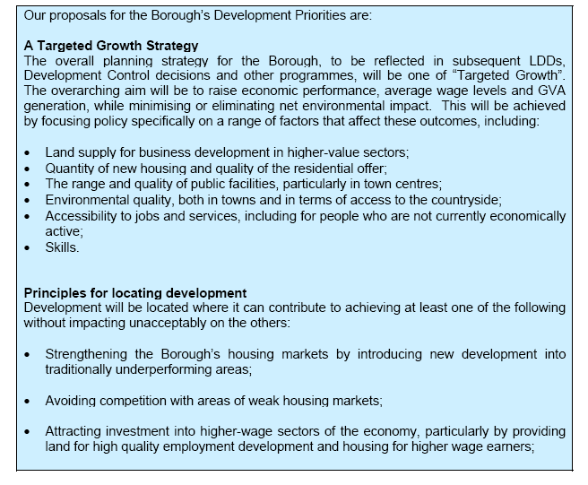
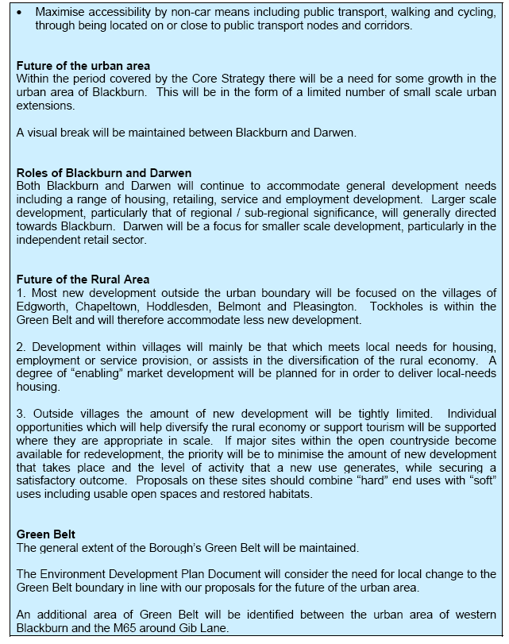

APPENDIX 2

Blackburn with Darwen Preferred Option Consultation Response

Ribble Valley Borough Council would like to take this opportunity to thank Blackburn with Darwen Borough Council for consulting us on the Preferred Option Core Strategy report.

Ribble Valley supports the Preferred Option, acknowledges that it meets all nine tests of soundness and only has the following comments to make on the overall development strategy.

Borough development priorities: Page 41: Key consultation questions

- In relation to the impact of the Preferred option on the Ribble Valley, it would have been useful to have been given a little more information on development strategy for the north of the Blackburn with Darwen borough. The key diagram on page 40 indicates that out of the open countryside areas, development along the Ribble Valley border will be a focus for general development, including large scale, regionally/ sub-regionally significant development. This suggests that large-scale development could impact significantly upon the Ribble Valley borough.
- For the borough of Blackburn with Darwen the preferred option does represent the right balance in our view. Developing the economic base of the borough whilst ensuring that environmental considerations are given adequate significance is important to ensure sustainable development.
- Although it’s good to see HMR supported and permission/completions figures relating to the successful implementation of the Interim Policy Statement to date, perhaps proposals should be wary of placing too much reliance on the HMR agenda continuing? Using the HMR agenda to deliver, part of the borough’s growth agenda- would this continue if the HMR agenda were no longer in operation? Should more reference be made to the forthcoming RSS figures here?
- Small-scale urban extensions seem the sensible approach, but will it be sufficient if the economic boom predicted as a result of the core strategy occurs. Will some degree of higher density development not be necessary at some stage?

In terms of the impact of the Preferred Option on the Ribble Valley, it is recognised that the Core strategy aims to include ‘policy hooks’ on which other LDF policies will hang and it will be within these LDDs that more specific potential impacts on the Ribble Valley will be identified. Ribble Valley therefore requests that it continues to be consulted on future LDF progress

