

Project: Condition Survey Report

Longridge Youth and Community Centre

Location: Townley Buildings, Berry Lane, Longridge, PR3 3JP

Date of Report: 18th May 2009

Surveyor: Tim Lynas BSc (Hons) MRICS

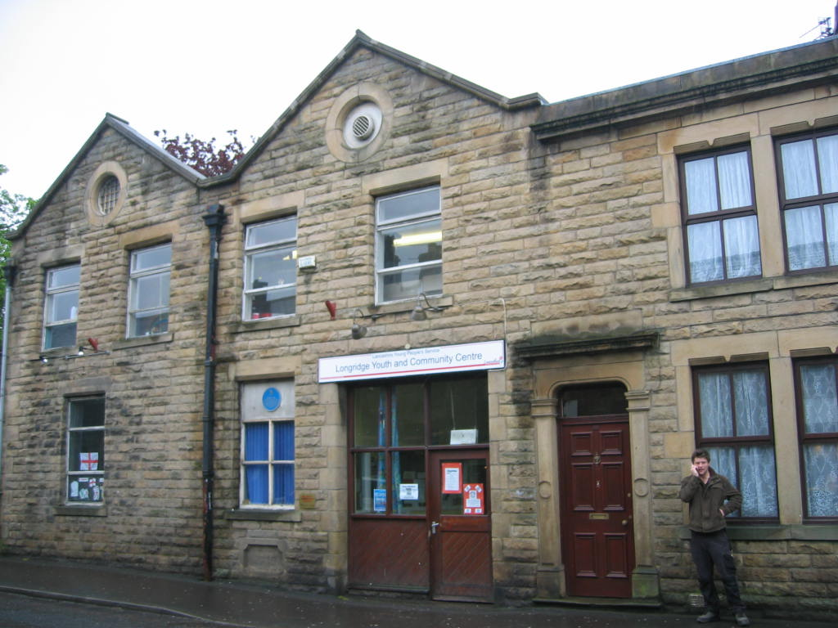

Page 3 Introduction
Page 3 Executive Summary
Page 4 Background and Context
Page 4 Construction Summary
Page 4 External Condition
Page 4 Rental Income
Page 5 Occupation and Use
Page 5 Funding Application
Page 5 Conclusion

Introduction

Instructions were received from Ribble Valley Borough Council Asset Management Group to inspect and report on the condition of the above named property and to look at the situation in relation to the lease.

Executive Summary

The property is in a poor state of repair and has a significant backlog of external maintenance. Ribble Valley Borough Council have repairing and redecoration obligations under the terms of the lease for the externals and structure of the property.

The internals are the responsibility of the tenant, these appear to be in a functional if dated condition. The lease has expired and the tenant are holding over.

It is therefore advised that the following options should be considered:

Option A

A new lease is granted, subject to negotiations on terms and conditions. Agreement is sought on the levels of rent, repairing obligations and length of term.

Option B

The lease is brought to an end and the tenant is given notice that we will work with them to find alterative accommodation. The property is converted into housing, commercial or mixed use.

A purpose built facility is provided on the Civic Centre site to accommodate the Youth Service including workshop rooms, dance studio and activity spaces. This consolidates the community service delivery and supports the vision of the community hub at this location.

Background and Context

In summary I understand that:

- The property was built circa 1890
- It housed the Fire Brigade from 1939 until 1967
- Lancashire County Council have leased the property from 1968
- It has a gross internal area of around 3,500 sq ft.

The semi detached two storey property is located on a vehicular street in the centre of Longridge. The adjacent buildings comprise of a mixture of residential and other community service properties. To the East and South the site faces onto a park and bowling green.

The property is not listed although it is within a conservation area. As such all works carried out to the external of the building must be like for like and in keeping with the surroundings.

Construction Summary

The property is of traditional load bearing stonework construction with pitched slate roof. The external elevations includes timber framed windows, timber doors and metal rain water goods. The ground floor slab is solid concrete with suspended timber upper floors. The property a small extension with flat roof to the east of the property.

External Condition

During my inspection the following points were noted:

- The external elevations require new windows and doors.
- The roof requires the renewal of missing, slipped and damaged slates.
- The lead flashings adjacent to the chimney require renewal.
- The external timber and metal work require redecoration.
- The rain water goods require renewal and repairs.
- The gates to the rear car park require renewal.
- The flat asphalt roof requires renewal.
- The diagonal cracking to the rear elevation requires further investigations.

The above named repairs are likely to cost between £15,000.00 and £20,000.00 excluding VAT and scaffolding costs.

Please note that it was not possible to access or inspect the central part of the pitched roofs, or the full roof space.

Rental Income

The property currently provides a rental income of £2,200.00 p.a. If this space was put on the market for office or retail in a good condition it could provide a rental income upwards of £30,000.00 p.a.

Occupation and Use

The centre is heavily used and offers a variety of services throughout the week. This includes:

- Dance workshops
- Drama workshops
- Duke Of Edinburgh training
- Young volunteers 14+,
- Young volunteers 16+
- Youth council
- Youth bank
- ‘Chillin’ drop in with sexual health professionals
- Youth arts
- Media group
- I-gen (inter generational links)
- 5 – 11s group

The centre is available to members of the public on a drop in basis:

- IT training
- Use of computers

Funding Application

I understand that the Youth and Community Service have applied for funding to improve the facility. This application is reported to total £185,000.00 and includes an internal refurbishment along with the renewal of external windows, doors and signage.

The Youth and Community Service submitted their bid on the 29th May, the Capital Bank are now considering the application and will respond by the 10th June.

Conclusion

For the purpose of its current use, this property is in a functional condition, however external repairs are required in the short term. It has the potential for redevelopment in the medium term, although this could be brought forward if alternative accommodation could be provided for the current tenant.

