APPENDIX 1

RIBBLE VALLEY SPAA
VISION DOCUMENT AND DELIVERY PLAN

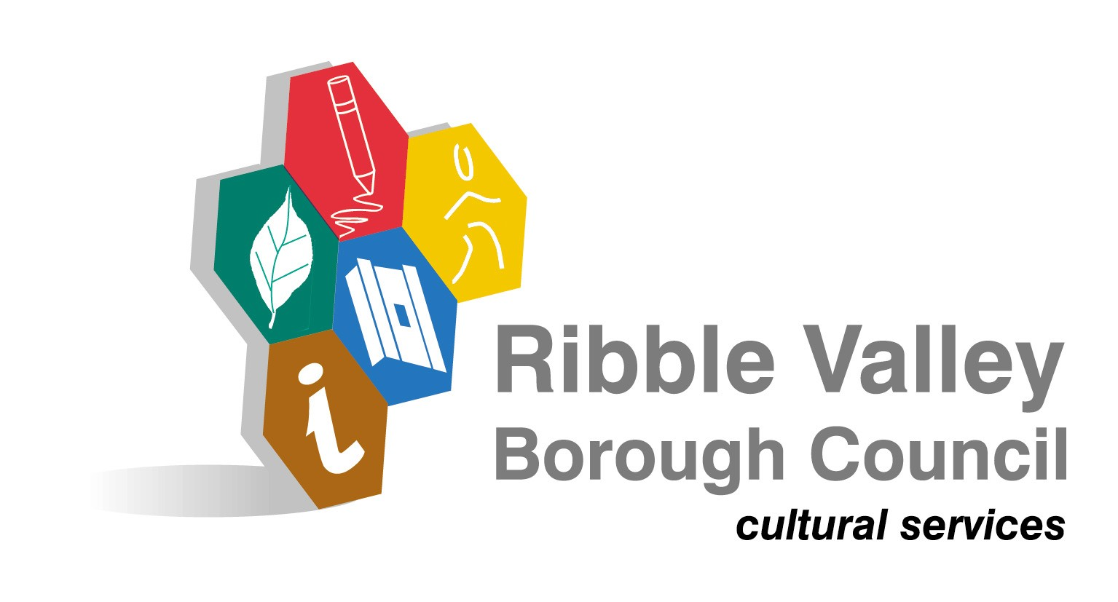

CONTENTS

Section 1- Where are we now?

  - Introduction
  - Strategic Landscape and Local Drivers
  - Establishing Priorities Through Local Needs

Section 2- SPAA Aims and Objectives and Themes

2.1 Strategic Aims and Objectives

Section 3- Delivering the Vision

3.1 Delivery Plan Themes
3.2 Delivery Plan and KPI Summary Sheet
3.3 Monitoring and Evaluation

APPENDICES

Appendix 1- Delivery Plan
Appendix 2- KPI Summary Sheet
SECTION 1- Where are we now?

1.1 Introduction

The primary terms of reference of the Ribble Valley SPAA is to work in partnership to directly impact on increasing participation levels and widening access to sport and physical activity for all residents of Ribble Valley.

Ribble Valley has a considerable track record of working in partnership with representatives from the community, voluntary and private sectors and through the Ribble Valley Local Strategic Partnership (RVLSP) aims to ensure that the community has involvement on all the thematic groups within the partnership structure. One of these being the Strategic Health Improvement Group and this will specifically tackle health inequalities and improve well being in the Ribble Valley by advocating the development of the SPAA and subsequent delivery plan.

Findings from the Active People Survey, 2006 shows that 19.7% of adults 16+ participating in at least 30 mins of sport and physical activity of moderate intensity on three or more days a week in Ribble Valley. This is well above the national average and highlights the need to retain high levels of participation in sport and physical activity. The trend of poor participation is more noticeable in the following groups:

- Women and Girls
- 45 and over
- Lower Social Economic Groups

This document provides an overview of the current position, data analysis which forms the basis of the identifications of local priorities and the strategic themes which will drive the delivery plan to help Ribble Valley achieve the 1% increase in participation.

1.2 National and local Drivers

Delivery System for Sport: National and Regional Context

The government has set a national target to widen the base and increase participation in England by 1% annually, which equates to approximately 569 people across the Borough. To achieve this in Ribble Valley then it will be necessary to establish a Sport and Physical Activity Alliance, which serves to oversee strategic planning and ensures that all the different agencies, organisations and investors are brought together in a more coordinated way than existed previously.

The Ribble Valley SPAA will;

- Be a group of delivery agents from a range of relevant organisations and sectors
- Identify local needs and potential interventions and develop a locally shared vision with the buy in from key partners including the Local Strategic Partnership
- Secure resources from a broad range of partners to deliver the identified interventions and outcomes
- Focus upon building capacity to increase participation and widen opportunities

Ribble Valley embraces the guidance which sets out the SPAA as the mechanism for planning and delivery, leading change and improvement locally with the support and coordination of Lancashire Sport.

In order to support the achievement of the desired outcomes Sport England are investing in each SPAA and a figure of £161, 000 has been identified as leverage to increase inward investment into Ribble Valley projects.

Regional Context

The North West Plan for Sport and Physical Activity identifies five themes which are either in most need of intervention or have a significant contribution to make in meeting participation targets:

- Enhancing the sporting infrastructure.
- Improving health and well-being.
- Developing education in schools.
- Benefiting the economy.
- Creating safer and stronger communities

Each of the above themes, are relevant to some degree in Ribble Valley but with sporting infrastructure, health and well-being and safer and stronger communities being of greater importance.

County Context

Changing Lives-is the strategy for Lancashire Sport. Its vision to develop a participation culture across the county is delivered through focusing upon the core themes contains in the regional plan for sport with young people as an additional priority theme. It is a shared document across the County, Unitary and District Councils within Lancashire.

Service Level Agreements are developed with local authority partners, which set local priorities and targets and the support required to deliver them. The LAA is led by Lancashire County Council and involves a wide variety of partners in delivering a range of outcomes which will have a significant effect on the quality of life of people living in Lancashire.

Ribble Valley Local Strategic Partnership

The Ribble Valley Strategic Partnership (RVSP) was established in 2002 to deliver the Community Strategy. A sub-group of the RVSP is the Strategic Health Improvement Group (SHIG) and this group has approved the development of the Ribble Valley SPAA.

The Executive Group is incorporated within the SHIG and its role is to develop the Action Plan, secure the necessary match funding, initiate appropriate performance management frameworks and meet any governance requirements.

Delivery Groups are to manage the activity to meet agreed outcomes. There are two sub-delivery group sub-divisions feeding into the executive group under the headings of “Participation through partnership” and “Infrastructure/Access”. The Partnership Structure is shown in Appendix 1.

1.3 Establishing Priorities Through Local Needs

In setting out a vision for the Ribble Valley SPAA it is important to reflect on the key components of relevant strategies and information sources.

The Community Strategy for Ribble Valley is (currently under review) identifies as a priority “actions relating to the Sports Development Officer’s work with young people and increasing participation in leisure activities by the disabled”; achieving access for all and targeting support to potentially disadvantaged groups.

The Sports and Recreation Strategy which this document will effectively supersede attached significance to the following:

- Promoting a healthy environment and lifestyle.
- Enhancing sporting and leisure opportunities within the Borough.
- Improving our ability to consult with people, especially hard to reach groups.
- Working with others to provide services for people where they live.
- Preserving and improving accessibility for people in rural areas.

A considerable amount of baseline data has been collated with respect to establishing the Council’s position in respect to the strategic indicators which have been identified:

Demographic Profile

The population of the Ribble Valley is currently estimated at 56 900 (ONS 2005 mid year projections) of whom approximately 25 000 live in the town of Clitheroe. Ribble Valley is the largest geographic area within Lancashire, but having the smallest population. Sparsity of population is therefore a key feature- on average 98 people per square kilometre compared with 354 nationally. There has been an increase of 5.2% in the overall population of the district since 1991 and is predicted to rise by 10.4% over the next 10 years. A relatively small proportion, less than 2% is from an ethnic minority background. The population is relatively old with a greater than average number of residents over the age of 65, coupled with a lower than average number of young people aged 24 and younger.

Ribble Valley is a relatively affluent area, being ranked 283 out of 354 in the indices of multiple deprivation for local authority areas in England. No wards feature in the 25% most deprived but 5 rural wards do feature within the worst 10% under the Access to Services Index. Unemployment is lower than the national average and earnings are higher. This however masks structural problems within the areas employment opportunities with a disproportionate number of employment opportunities being low skilled and relatively low paid.
Key Message:
Whilst the demographic profile presents a generally healthy picture, there are areas that represent potential actions for the SPAA. These are:

- Health issues surrounding an aging population; and
- Access to services in isolated communities.

P2- The development of new initiatives within local facilities currently under
utilised will aim to overcome the issue of rural isolation

There are pockets of underrepresented groups within Ribble Valley but the SPAA feel that effort should be placed on inclusion of all groups rather than concentrating on one owing to the lack of critical mass of one specific group.

P4- An inclusion coach will deliver a programme of sessions aimed at all groups this will include building partnerships to help deliver female only sessions and subsidised leisure cards

Audit Commission Area Profile

The data profile for Ribble Valley contains a range of quality of life indicators some of which are useful in building a picture of resident satisfaction with services.

The information gives a favourable picture of Ribble Valley in terms of satisfaction with facilities and services. Despite being in the top quartile performance, residents have cited the development of activities for teenagers as their number 1 priority.
Key Message:
This suggests that in addition to concentrating on meeting the needs according to the demographic profile of the area it is important to consider exploring the opportunities for young people in Ribble Valley.

P3- The mountain biking development will help improve provision and range of activities for all the population of which a core user group will be 13-19 year olds

Active People’s Survey

The Active People’s Survey is the largest single research study into participation and volunteering in sport and physical activity. Whilst Ribble Valley achieves top quartile scores with the headline participation (24.28%) and volunteering (5.87%) indicators, there are some concerns behind these headlines.

Figure 1.1 overleaf shows that a significantly higher proportion of men (43.3%) are participating in at least 3 sessions of 30 minutes moderate intensity physical activity compared to only 32% of the female population. The trend of lower participation rates amongst the female population of Ribble Valley is shown by the statistic that 48.2% do not participate in any physical activity.

Figure 1.1 Participation Rates by Gender

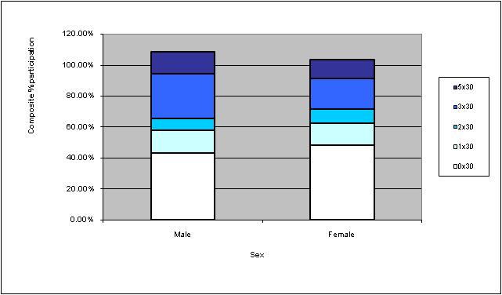

40% of the population between the ages of 25 and 34 participate in 3 sessions of 30 minutes physical activity compared to 28% between the ages of 35 and 44 and only 18% between the ages of 55 and 64. Figure 1.2 shows that participation in physical activity significantly reduces by age.

Figure 1.2 Participation Rates by Age

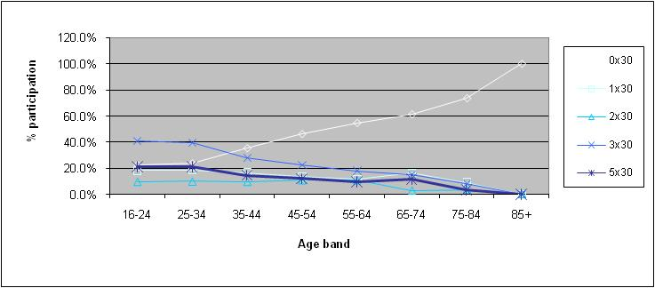

In addition to the concerns of female participation rates and the significant reduction in levels of physical activity as one gets older, it is apparent that participation rates are also significantly lower than average amongst people from lower socio-economic groupings. For example Figure 1.3 overleaf shows that 66% of NS-SEC8 (long term unemployed) do not participate in any physical activity and 0% participate for the recommended 3 times 30 minutes. This compares to NS-SEC1,2 where 28% participate in 3 times 30 minutes physical activity.

Figure 1.3 Participation Rates by Socio-economic Grouping

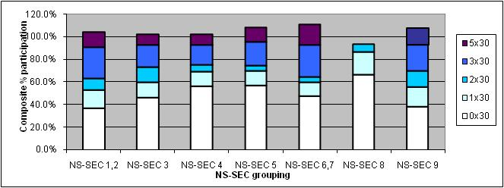

When looking at sport specific participation Figure 1.4 shows that the main participation sports are football, golf, running, swimming and gym. In addition it is important to show that even though participation amongst women is relatively low in comparison to men the key participation sports amongst women are swimming, gym, aerobics and badminton. This sort of analysis can be used to plan interventions when targeting these groups.

Figure 1.4 Sport Specific Participation Rates by Gender

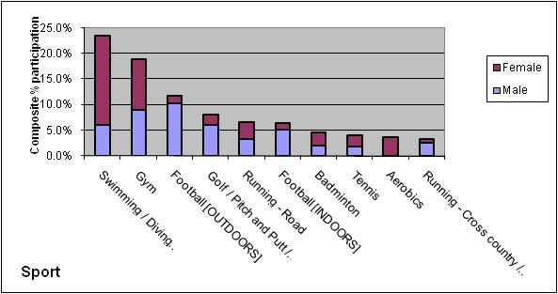

Figure 1.5 overleaf shows the most popular participation sports by age group, outlining that activities such as golf, gym, aerobics and swimming could be used within interventions targeting the over 50s. Whereas the interventions aimed at younger people would be more suited to utilising team sports and the natural environment for activities such as football and running.

It is important to note here that there is a distinct drop off in team sports after the age of 25. Through developing a stronger sporting infrastructure and working with locally identified priority sports that participation in clubs/ team sports could be increased by promoting to the 25-45 age group schemes such as ‘back to netball’ or coaching/ volunteering opportunities.

Figure 1.5 Sport Specific Participation Rates by Age

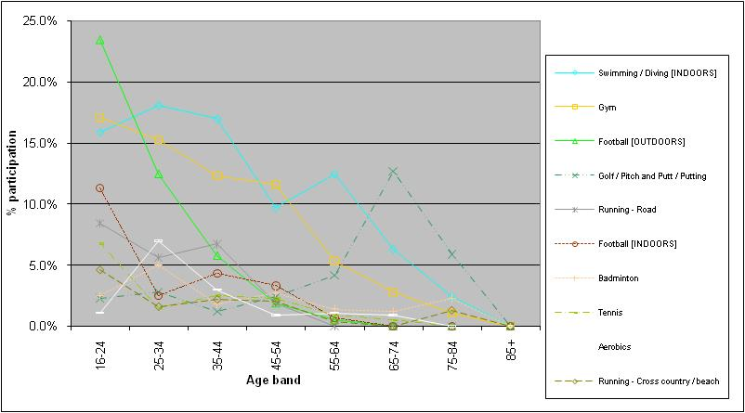

Sporting Infrastructure

The key findings are that 5.9% of the population are volunteering which is above the national average. The majority of these volunteers are male and between the age of 16-34. The trends in participation are also replicated amongst volunteers as fewer women, people from ethnic minorities and lower socio-economic groups currently volunteer.

25% of the population are currently club members. This figure is in line with the regional and Lancashire average. This provides encouraging statistics for the SPAA that there is a decent platform to enhance development al work. However, the trends continue as there are less female club members in addition to membership decreasing by age. 17.1% of people received coaching tuition in the past 12 months a figure which is below the national average, a figure that suggests a need for more coaches.

All these figures provide an opportunity for the SPAA and indicates that investment could be channelled to enhance and further develop the local sporting infrastructure.
Key Message:
In summary the key findings of the Active People Survey are as follows:

- Female participation is significantly lower than male participation at 19.8% and 29.1% respectively.
- Non participation grows significantly with age from 59% of ages 30-34 to over an average of 80% for those over 50.
- Participation in the more formal team sports and facility based activities decreases with age with more informal and outdoor pursuits more popular.
- Swimming, gym and aerobics most popular amongst women as oppose to men whose participation is higher in more formal sporting activities and outdoor pursuits
- There is also a correlation between earnings and participation with non-participation 24% greater between the lowest and highest incomes.

P1- Development of a series of mass participation events utilising the natural environment to overcome the barriers of cost and engage in more informal activities such as walking and cycling to engage with those groups who do not participate in formal sports.

P2- Development of a range of activities within local village halls to meet the needs of the local population. This will include the delivery of aerobic based activities to target the female population.

P3- The natural environment will be utilised to develop mountain biking for the population who are more likely to participate in less formal indoor sports for example male 16-45 age groups.

P4- Delivery of inclusive sessions for those underrepresented groups to engage in activity

- Volunteering and club membership rates are above average but are dominated by male 16-34 population.
- Coaching figures are below average

The delivery plan will include improving the sporting infrastructure by employing club development officers to work with clubs to increase membership figures, number of volunteers, coaches and accredited clubs
Active Places Database

The Active Places Database measures the percentage of the population within 20 minutes travel to a range of sports facilities. At 58.2% the Ribble Valley scores highly, being in the top quartile.

The vast majority of this access relates to the main population centres where the bulk of facilities are located. However, there are large less densely populated areas where, under the current list of facilities on the database, such access is never likely to be achieved. They are facilities such as play areas, schools and village halls that have the potential to fill the gap but, in some instances, do not provide opportunities to participate in sport and physical activity at present.

The database also assumes that an appropriate mode of transport is available. Whilst there is a relatively high proportion of 2 car families in Ribble Valley, it is by no means a universal provision. Coupled with the increasing pressure on rural bus services, access to facilities and activities in isolated rural communities, is significantly lower than in the main population centres.
Key Message:
Therefore whilst the Active Places Database provides a useful snapshot of access to services, further investigation reveals that there are pockets of deprivation, particularly in rural communities. Whilst there may be facilities to fill the gap, they are not being fully utilized at this moment in time. These findings will be used to identify the key areas to target interventions which will improve provision and increase the usage of facilities which are currently under utilised.

P2- will improve provision within Longridge by increasing health and fitness provision and from this central hub an activity deliverer will work with a network of practitioners to establish sessions within the existing network of facilities which are currently underutilised.

Ribble Valley Locality Health Profile

It is often perceived that Ribble Valley has less relative health need than the rest of East Lancashire, however there are issues affecting health within the borough that cannot be overlooked. The age profile for Ribble Valley is changing with proportionately fewer young and middle aged people than older residents, bringing associated implications for health and social services. It is predicted that the proportion of all the people is set to rise over the next 10 years. Ribble Valley residents have relatively less risk factors for coronary heart disease than the rest of East Lancashire. Rural areas such as Ribble Valley often have significant pockets of deprivation and disadvantage that are hidden in an overall picture of affluence. People living in rural areas with limited resources have high living costs and restricted choices. Access to services, transport, employment, affordable housing and facilities can be a problem for specific groups such as young people and the elderly. People on lower incomes without resources are likely to have the greatest need for health and social care and are disproportionately affected by these issues.

There needs to be more opportunity for equitable access to services and facilities. This could be improved by applying outreach models for service provision such as mobile units or better use of community facilities such as village hall and by improving transport access to help reduce isolation and improve access to services. Opportunities for a healthy lifestyle need to be improved and developed through joint working across a variety of agencies including PCT, local authorities, education and voluntary services.

The Mental Health Indicator used in the generation of the 2004 English indices of Deprivation reveals that in Ribble Valley there are 40 Super Output Areas (SOA’s). Of these 2 are ranked in the worst 20% nationally on the Mental Health Indicator. This data is based upon the level of individuals with anxiety or depressive disorders. In Ribble Valley the proportions of people reporting three or more symptoms on the General Household Questionnaire (GHQ), is higher amongst females than males; (1 in 4 females and 1 in 6 males). There is a lower proportion in the younger (18-39) age group.
In comparison with a similar survey undertaken in 1996 there has been little change over the 10 year period in the proportion of people reporting three or more symptoms on the GHQ.

The distribution of Mental Health Indicator by SOA in Ribble Valley is shown below; with the greatest incidence being shown around the Billington and Whalley areas.

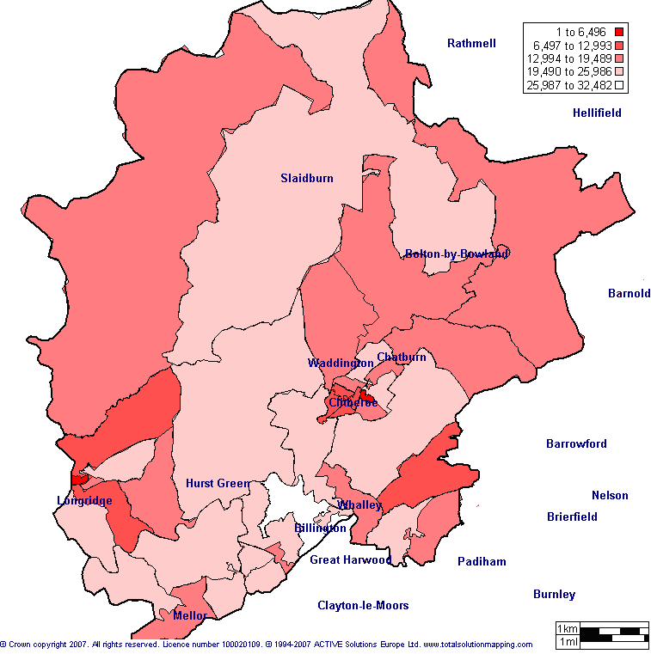

Addressing Obesity in Ribble Valley

Reducing obesity and mortality from long term conditions associated with it has been identified as a priority area for action by the Ribble Valley Strategic Health Improvement Group. A Physical Activity and Nutrition Workshop has served to develop an evidence base action plan for Ribble Valley and key performance targets for improving Nutrition and Increasing physical activity have been determined. Key projects which are currently being delivered to reduce obesity are referenced within the delivery plan. Recently funding from the PCT has been drawn down by the SHIG to deliver a series of weight management and awareness raising sessions for women which it is hoped in turn will result in more people becoming physically active.

This analysis of needs serves to help identify priorities for the Ribble Valley SPAA and how these priorities contribute to community service outcomes. Improving the health of the nation and tackling health inequalities are high priorities at the current time and this SPAA recognises the value of the Governments Choosing Activity and the is committed to working with the PCT towards raising physical activity levels across Ribble Valley.

Key Message:
Despite the generally favourable situation there are pockets of deprivation across the Borough and preventative health measures are specifically important in these areas. These measures will aim to;

- Reduce the likelihood of ill health and reduce mortality risk
- Help to tackle obesity
- Encourage the adoption of a healthy lifestyle
- Contribute to older people leading healthier lives

P1, P2, P4- All projects will help improve the health of local people by delivering an accessible programme of sessions which be inclusive of all groups especially over 50s. The walking and cycling events in P1 and the more targeted work within village halls in (P2) and the specific work of the inclusion officer (P3) will all help improve the current baseline
Crime and Disorder Profile

Statistics taken from the British Crime Survey show that Ribble Valley is the safest area in the County to live across all crime categories.

Criminal damage however is the area’s main volume of crime, representing a 19% increase since 2003/04 in assumption that young people are responsible for a proportion of such incidents. It is worth noting however that the actual numbers of crimes are relatively low compared with our neighbours and so a spate of incidents by a small number of people can have a significant impact on the percentages.

The issue was highlighted during the “Beyond Sport” project where there were only a small number of individuals in danger of entering the criminal justice system and therefore difficult to have sport as an ongoing offer to combat such activity.

There are examples where the provision of facilities has had a significant impact on juvenile nuisance. The provision of skate parks in both Clitheroe and Longridge has helped reduce incidents and both town centres have gained significant local community support and praise.
Key Message:
Although the role of sport and physical activity in reducing youth associated crime is unlikely to be a key priority, there are opportunities to work with local communities to explore the development of neighbouring facilities and activities to reduce the perception amongst young people that “there is nothing to do and nowhere to go” where they live.

Strong local sporting infrastructures reduce the need for people to travel long distances and sport can encourage walking and cycling as alternative means of transport for everyday travel. Given the accessibility difficulties presented by distances to existing service provision there is a need to generate sporting participation at a local level.

The delivery plan will look at improving sustainable travel and improve access to facilities. All funded projects will have some impact on improving levels of provision and increase the range of activities on offer to overcome issues of anti-social behaviour

PESSCL School Sport Survey

The information relating to participation in School sport across Ribble Valley is not comprehensive as the majority of primary schools have only commenced involvement as recently as September 2007 and so the figures available represent a baseline produced from school audits. The level of participation in 2 hours quality P.E. varies between the key stages 1-4, and the overall average is 51% which is well below the required PESSCL target of 75% by 2006. However, the results are expected to improve when the development plan is re appraised this summer 2007.

Year 9 Survey 2004

Analysis of the participation trends across Ribble Valley schools reveals the following;

- There has been a significant increase in the numbers participating in extra curricular sport and Members of a Sports Club rising from 49% to 74% and 50% to 63.5% respectively since 2001.
- Awareness of the Boroughs leisure facilities amongst young people was greatest for Ribblesdale Pool, Longridge S.C. and Roefield L.C. but there is significantly lower awareness of all leisure facilities amongst young people than there is compared to adults surveyed.
- The level of non-swimmers is lower in Ribble Valley compared with the Lancashire and North West averages; (10.5% compared to over 15%).

Key Message:
The fundamental aspect of Every Child Matters national framework is that services are built around the needs of children and Young People. As identified under the Crime and Disorder profile there is a perception that there is little in the way of activities for young people to do; and the SPAA recognises the importance of generating stronger social networks and more cohesive communities through the delivery of sporting activities.

There is a need to improve opportunities for 13-19, particularly in rurally isolated areas and this is important if the rural population increases as the evidence suggests. Sport can contribute to the personal development of young people and the potential to instigate involvement in a volunteer, coach or leadership role, is also acknowledged.

There is an opportunity through the SPAA to improve joint delivery and partnership working in this area between the School Sport Partnership and the Sport Development department at RVBC. The key areas where joint working could help are the establishment of more and improvement of existing school club links- concentrating on the transition of 14-16 year olds into post 16 sports participation and volunteering.

Sporting Infrastructure- people is a key theme within the delivery plan to establish a strong network of clubs in the area. The school sport partnership will also be a key partner in improving the community sport links with schools.

There are a number of projects which will have an element of under 16 participation and P3 will help provide a greater range of activities including 13-19 age group as a core user group

Community Consultation

A consultation exercise has been undertaken to obtain the views of a representative section of the community and a Community Conference was organise in April 2007 at Clitheroe Rugby Club. There were discussion groups around the following subject areas established through the above analysis;

- Elderly people
- Young People
- Health
- Community Safety
- Rural Isolation

The suggestions emerging from the groups were considered in preparing this action plan.
A subsequent community meeting was held in July as a follow on consultation exercise in order to consider the analysis of the main themes of the Ribble Valley SPAA.

Summary

The key messages from this analysis have been used to shape the SPAA vision, strategic aim, objectives and subsequent delivery plan themes. It is the aim of the SPAA to ensure that through the development of projects within the themed delivery plan that gaps in provision will be plugged and an increase in participation will be seen amongst target groups; the sporting infrastructure will be improved to establish a platform for development and there will be a knock on effect of improved health, community safety and partnership working.

SECTION 2- SPAA Aims and Objectives and Themes

Vision

A vision for Ribble Valley SPAA: ‘To develop a more active Ribble Valley by increasing awareness of sporting opportunities and associated health benefits; through the provision of inclusive interventions supported by a co-ordinated sporting infrastructure.’

2.1 Strategic Aims and Objectives

Strategic Aim

To establish a multi-agency approach towards increasing participation in Sport and Physical Activity by 1% per annum and through consultation with local communities initiate projects which give rise to immediate and sustained participation over the long term.

Objectives

- Raise the awareness of sport and physical activity opportunities and the benefits participation in sport and physical activity has on tackling health inequalities and establishing healthier communities
- Develop a series of mass participation opportunities utilising the natural environment
- Initiate projects which contribute to safe, strong and sustainable communities
- Develop the local sporting infrastructure in terms of facility usage and programming, sport specific club development and workforce development
- Develop targeted interventions to meet the needs of specific target groups which are under-represented in respect to participation in physical activity and includes the needs of children and young people.

Key Outcomes

This action plan is based upon a consideration of national and local priorities.

In a national context the intentions are:

- To increase participation levels and sport and physical activity by adults and young people aged 16 and above, and increasing the number of individuals from priority groups who engage in at least 30 minutes of moderate intensity exercise at least 3 times per week. (PSA 3 target)
- Halt the year on year increase in obesity amongst children under 11 by 2012 as part of a broader strategy to tackle obesity in the population as a whole. (PSA 2 target)
- Increase the percentage of school children who spend a minimum of 2 hours quality PE and school sport per week. (PSA 1 target)

In addition the core following delivery system targets will form a template for working up specific local projects:

- KPI1 – increasing the number of new participants.
- KPI3 - increasing the number of members in Local Clubs.
- KPI4 - improving standards in sport/ organisational accreditation.
- KPI5 – increasing the number of new coaches.
- KPI8 – increasing the number of new volunteers.
- KPI17 - increasing leverage into sport.

The SPAA will also embrace the national target of an increase in participation in England by 1% annually through the single system for the delivery of community sport. This will mean an increase of 569 new participants in Ribble Valley.

SECTION 3- DELIVERING THE VISION

3.1 Delivery Plan Themes

The vision, aims and objectives of the SPAA has driven the development of the delivery plan structure, which will have four core themes. These are:

- Increasing Awareness
- Opportunities/ Mass participation
- Infrastructure- Facilities
- Infrastructure- People

In addition there will be the cross-cutting theme of ‘Intervention’ which will promote and ensure inclusion and targeted work across all sport and physical activity delivery locally.

Appendix 1 summarises the delivery plan themes and project structure. The following section outlines in more detail the key work which will be undertaken within each theme.

- Increasing Awareness

The greatest impact upon participation levels across all the population and specifically across the target groups; (older people, young people, women and rurally isolated), is likely to be through the generation of increased awareness in opportunities through mass marketing and media campaigns. It is envisaged that the organisation of special events and festivals around activities which are representative of the interests of the population and which are easily accessible, are held as part of coordinated approach to affect personal attitudes and remove barriers towards participation in physical activity. The events to be organised will have a multi-sport focus which promote existing facilities and clubs and incorporate signposting to new opportunities.

- Opportunities and Mass Participation

In addition to increasing awareness of the benefits of exercise and more active and healthier lifestyles it is essential that there are appropriate activities accessible to the community. The two main areas which will be focused on are walking and cycling. Ribble Valley currently has an established Led Walks Programme, which is financially supported by the Hyndburn and Ribble Valley PCT and further development opportunities have been identified.

Ribble Valley is a popular are with cyclists and the Borough has a Cycling strategy which places emphasis on recreational cycling and in particular mountain biking in establishing and developing cycle trails across the Borough.

Project 1- will build upon the existing walking and cycling infrastructure and extend the work of the existing walking and cycling officers to help them increase participation by delivering a calendar of special events linked to cycling and walking as activities to attract the masses. Events will include ‘Bike and Hike’, festivals, family cycling events and will utilise the existing routes, volunteers and natural environment.

- Infrastructure- facilities

Taking into account the limited range of existing Leisure Facility provision available at the established centres, there is believed to be potential to developing the framework and activity programmes from certain village venues. These venues will effectively emerge as community hubs offering activities which cater for local needs and which attract public and potentially private investment. The Coordination of the activity programmes currently undertaken by local volunteers will need development support and assistance to build upon the core activities. It is proposed to identify a Community venue Coordinator role to develop this objective.

There are a number of village halls across the Borough which currently provide for community needs in a locally responsive manner, and it is believed that activity programmes could be coordinated in a more effective way with the involvement of representation from Hyndburn and Ribble Valley C.V.S.

Whilst it would appear from that Active Places database that there is a reasonably accessible situation in relation to sports facilities, the Sports Hall provision is limited in the range of activities and instruction available. It is also the case that village halls are under utilised and have potential for programme development. There are some examples where a
range of opportunities are provided at Chipping and West Bradford

Project 2- will develop a community gym in Longridge, an area where sport and leisure provision is poor and participation levels are low. This would become the hub for sport and physical activity in the area.

The activities, which might help in establishing a thriving hub of activity in each particular community, are;-

- Fitness For Life sessions
- Keep Fit classes for adults including; Circuit’s Tai-Chi or Yoga
- Organised led walks on a scheduled basis
- Organised cycling for families or individuals
- Activity sessions for the following target groups; 50+, 16-24 and women of all ages.

The project will also provide funding for an activity deliverer who will develop and deliver a programme of activities based upon local need 1) at Longridge and 2) throughout the existing village hall/ community facilities in outlying villages which are currently underutilised. This will help increase participation amongst the population by providing a range of activities based on local need.

Project 3- Recognising the current emphasis on health initiatives and the fact that there is a need to utilise the surrounding natural environment for participation there is an increasing emphasis on outdoor recreation and mountain biking plays a key part in this Sport and physical activity agenda. The demand for riding opportunities emerged from the consultation exercise and the Gisburn Forest Trails provide an opportunity to satisfy this as part of the Pennine Lancashire adrenaline Gateway project. This will encourage the widest possible public access to a biking experience and ensure that all providers in the area offer the highest possible quality of teaching and instruction to participants. The project will provide funding for the development of new routes, enhancement of existing routes and the opportunity to develop a series of events to increase participation.

- Infrastructure- people and clubs

This involves a combination of increasing Sports Club membership through emphasis on key sports and also raising the capacity to accommodate increased participation at clubs through the availability of more accredited clubs, qualified coaches and active volunteers.

The availability of sports specific funding from the respective Governing bodies may contribute towards the development of participation in the following focus sports; Football, Cricket, Rugby Union, Athletics, Netball and Swimming.

Cross- cutting- Intervention

There are individuals who are perceived as being unlikely to adopt a physically active lifestyle without the assistance of positive intervention measures. A range of health related programmes are currently available to Ribble Valley residents, including; ‘Heartwatch’, ‘Fitness For Life’, ‘Pathways to Work’ and Obesity and Weight Management programmes and there is considerable potential to further develop these initiatives across the community.

Project 4- Intervention is to be targeted at the focus groups and specific resources committed to breaking down the barriers experienced in each age group. The process of applying interventions most effectively is to be coordinated by the Borough Council Healthy Lifestyle team and an Inclusion Coach.

In particular, people with disabilities and special needs will be supported in accessing existing and new opportunities through the following ways;

- Directing concessions to individuals and their families through the availability of the Borough’s Leisurecard scheme.
- Establishing specific multi-skill activity sessions for school children in conjunction with the School Sports Partnership.
- Ensuring that individual needs are taken into account as part of attempts to increase participation in Walking and Cycling.

3.2 Partnership Working and SPAA Membership

The main functions of the SPAA Executive are to;

1. Ensure that there are effective mechanisms for securing, leveraging and channelling investment to ensure the maximum impact upon physical activity and sport at local level.

2. To create robust mechanisms of governance in order to monitor and elevate the impact of investment and thus be accountable to the community.

3. To consider reports from the respective Delivery groups and provide steering as to the achievement of project objectives and ongoing management as issues arise.

The membership of the Sport and Physical Activity Executive Alliance is to comprise of;
RVBC Officers and SHIG representative
County Sport Partnership representation
Primary Care Trust-Health specialist
Education representative- Hyndburn and Ribble Valley PDM/ Headteacher
Voluntary sector representatives from- Hyndburn and Ribble Valley C.V.S, Age Concern, Sports Forum and Youth Forum

It is anticipated that this group will meet on a monthly basis initially and less frequently once the work plan is in place.
Meetings are to be co-ordinated and serviced by RVBC. A chair and Vice-Chair will be elected by the membership, who will direct the work of the SPAA and ensure compliance with the accountability of the work structures.

Diagram 3.1 shows how the SPAA fits within the local decision making structure. The SPAA is strategically aligned to the Strategic Health Improvement Group (SHIG) of the Local Strategic Partnership and the SPAA is ultimately responsible to them. Ongoing support will be provided by the County Sport Partnership

Delivery Groups will be formed from the SPAA executive and will report to the Executive Group on a periodic basis, and the composition of the groups will reflect the nature of the theme area. There will be three delivery groups each leading on the four SPAA core themes. The strands are Participation- leading on the increasing awareness and opportunities/ mass participation themes and Infrastructure leading on the facilities and people infrastructure themes. It is envisaged that certain core individuals may be involved in all groups but there will be representation from specific agencies; who are considered to be best placed to initiate and drive the themes and subsequent projects towards the delivery outcome objectives in certain SPAA projects. The cross-cutting theme of Intervention which will ensure inclusion is promoted and embodied throughout local delivery will also have its own delivery group.

Diagram 2.1

SPORT AND PHYSICAL ACTIVITY ALLIANCE DELIVERY STRUCTURE

RV LSP

STRATEGIC HEALTH IMPROVEMENT GROUP (SHIG)

SPAA EXECUTIVE

Delivery Group
Participation: special events Mountain Biking

Delivery Group
Infrastructure: Village Venues
Delivery Group
Intervention

3.3 Delivery Plan and KPI Summary Sheet

The main projects are summarised in the Delivery Plan shown in Appendix 1.
These include;
- A marketing campaign to increase awareness of the opportunities available to participate in physical activity and sport across Ribble Valley, and the organisation of special walking and cycling events. (Theme 1 & 2)
- The provision of a Fitness Room facility and core physical activity sessions at Longridge Civic Hall as the initial phase of the development of activity programmes across village venues throughout the Borough. The creation of a coordinator post is implicit for successful delivery of the outcomes. (Theme 3)
- Provision of graded Mountain Bike cycle trails in Gisburn Forest to suit a range of abilities and previous experience in this activity. (Theme 3).
- Increase the capacity for sports participation within the Borough’s established focus sports and establishing specific development posts. (Theme 4).
- Identify the problems facing individuals and groups which are inhibiting participation and facilitate access to all the Delivery Plan schemes, paying particular emphasis to the target groups. The creation of an Inclusion Officer Post is fundamental to achieving the project outcomes. (Theme 5)

The contribution made by each project to achieving the key performance indicators is shown in the Overall CSN KPI Summary Sheet in Appendix 2.

3.4 Monitoring and Evaluation

There is a need to improve upon the current monitoring practices to embrace the collection of additional data necessary to demonstrate that increases in participation and physical activity have emerged as a direct effect of the implementation of the SPAA Delivery Plan.

The importance attached to evaluating the effectiveness of each project is recognised and the process will be undertaken with guidance from the Sport England Monitoring and Evaluation Toolkit. It is year plan.

Ribble Valley SPAA will liaise with Lancashire Sport and other SPAA’s especially across the East Lancashire cluster group to share good practice and help build up intelligence in relation to data collection through Geographical Information Systems (GIS Mapping).

Appendix 1

RIBBLE VALLEY SPAA- PROJECTS STRUCTURE

OPPORTUNITIES
INFRASTRUCTURE
FACILITIES
INFRASTRUCTURE
PEOPLE AND CLUBS
CAMPAIGNS PROGRMME
MEDIA
EVENTS
BRANDING
FESTIVALS
WALKING
CYCLING
SPECIAL EVENTS
SCHOOL TRAVEL PLANS

VILLAGE VENUES-ACTIVITY PROGRAMME DEVELOPMENT
ROEFIELD L.C.
MOUNTAIN BIKE ROUTES AT GUISBURN FOREST

SPORTS SPECIFIC DEVELOPMENT- MORE COACHES/ VOLUNTEERS/ ACCREDITED CLUBS WITH CHARTERMARK AND CLUBMARK
CROSS CUTTING THEME- INTERVENTION
DELIVERY GROUP EAST LANCS P.C.T
HEALTHY LIFESTYLES TEAM-RVBC
DELIVERY GROUP R.V.B.C WALKING AND CYCLING DEVELOPMENT OFFICERS, SCHOOL TRAVEL UNIT

DELIVERY GROUP COMMUNITY VILLAGE FORUM
HYNDBURN AND RV –CVS; LEISURE FACILITY REPS.

DELIVERY GROUP
SPORTS SPECIFIC DEVELOPMENT OPFFICERS
CLUB FORUM REPRESENTATIVES
AWARENESS

APPENDIX 2
Delivery Plan Template
Theme: _1._INCREASING AWARENESS___________________________

Action | Lead  Responsibility | Resources  Breakdown | Timescales | How will success be measured? | KPI’s/Outputs | CIF bid/Project Plan Ref if applicable
1.Campaign to encourage people to get more active and to increase awareness of the benefits of physical activity and sport across the whole community. This will include a specific programme of special events linked to Project 1 (Theme 2) | PCT  RVBC-Sports Development/ Leisure Services | Advertising through appropriate mediums and organisation of special events. | April 2008 onwards | Increased awareness of the opportunities to participate in sport and physical activity.  Active People Survey  (3x30mins) | KPI 1-Increase participation in the events promoted and linked to sporting opportunities; walking and cycling.  New adult participants are estimated in the specific sections under Project 1 (Theme 2) | No
2.Improve awareness of local agencies, initiatives and Activity programmes | RVBC-Leisure Services |  |  | Production of an Activity Database  More effective targeted marketing by application of Active Places, GIS mapping and Sport England Market Segmentation information | This action will contribute to the achievement of PSA 3 target. | No
3. Provide support and service for adults and children who want to manage their weight. It is especially focused on young women | PCT  RVBC-Sports Development/Leisure Services  Healthy Schools  Commercial providers | An initial proposal to deliver sessions for women’s groups has estimated costs of approximately £9K from;  PCT Partnership match=£6K and £3K in kind. |  | Increased number of participants measured by:  No. of people on the weight management referral care pathway  Age/gender/ethnicity/overweight  Obese  Improved outcomes in terms of weight reduction and attitude towards take up of exercise. | KPI 1- Increased participation- 50 adult women per annum  KPI 8- Increase volunteers by 3 per annum | No

Delivery Plan Template
Theme: _2. OPPORTUNITIES/ MASS PARTICIPATION____________________________

Action | Lead  Responsibility | Resources  Breakdown | Timescales | How will success be measured? | KPI’s/Outputs | CIF bid/Project Plan Ref if applicable
1.Extend existing programme for walking and cycling for the community using the delivery of special events and regular programmed walks far target groups  Organisation of associated activities including orienteering and running events | RVBC- Led Walks Officer  RVBC- Cycling Officer | Additional Walking and Cycling Officer time and volunteer support for a two year period costs= £10K from SPAA funding, application for SHIG and East Lancs. PCT funding for additional 5K. £2K in kind for promotion | Programme of special events to be organised from Summer 2008 | Increase in number of participants in walks;  Base Level of 4000 per year to increase to 6000 after 2nd year.  Increase in number of volunteers assisting in delivery of the walks  Increase participants in cycling; Establish base level in first year and 20% increase generated from;  School pupils  Families and individuals attending organised cycling events. | Walking led activities-  KPI 1-New participation increased 535 adults and 150 under 16s over 3 years  KPI 8-Volunteers increased = 30 new volunteers over 3 years  Cycling led activities-  KPI 1- New participation 200 new adult cyclists.  150 new under 16 cyclists  KPI 3- 50 adult and 25 under 16 per year  KPI 8- Volunteers = 20 new volunteers | Yes Ref:P1  Total request in respect to combined Walking and Cycling events= £10,000 SPAA and 5K match and 2K in kind
3.Support Schools to encourage walking and Cycling schemes which are also to raising PE standards | School Sport Partnership for Hyndburn and Ribble Valley and LCC Travel Unit |  | 2008 0nwards | Increase in number of schools with Travel Plans | This will contribute towards PSA 2 and SSP targets for healthy schools | No
4.To provide activity programmes during and outside school hours for young people who are identified as inactive and clinically obese | RVBC- Sports Development and School Sport Partnership | Costs attached to facility/ venue provision for the activity programme |  | Increase in school children participating in physical activity and showing a positive improvement in physical ability and behavioural attitude. | This will contribute to PSA 1. | No
5.Extension of the current Leisurecard scheme to include specific activities for;  Over 50’s and women aged16-24 | RVBC | Personalised Leisurecard and activity concessions | April 2008 onwards | Increase in participation amongst the Over 50’s and Women aged 16-24, through uptake of specifically programmed activities | KPI 1- increase from 409 to 550 in first year and then 100 per year= 341 adult Leisurecard members | No

Delivery Plan Template
Theme: _3. COMMUNITY INFRASTRUCTURE-FACILITIES____________________________

Action | Lead  Responsibility | Resources  Breakdown | Timescales | How will success be measured? | KPI’s/Outputs | CIF bid/Project Plan Ref if applicable
1. Capital programme-To provide a Fitness Room and Activity programme representative of local need at Longridge Civic Hall | RVBC- Village Hall Coordinator and Longridge Social Enterprise Group | Total capital cost- Provision of Fitness Room- £215 K  Match- £195K RVBC as capital | Fitness Room and staffing presence to be in operation by April 2008. | Increase in participation through use of the Fitness Room and programmed activities by target group;  Young people (14-16)  Young women(16-24)  Women 24+  Elderly 50+  Disabled | KPI 1- New participants increased at this venue by 350 adults per year and 150 juniors per year over 3 years.  KPI 2- Throughput increased from 20 000 to 40 000 over first year and then 1 000 per year= 40 000  KPI 5- New coaches= 7  KPI 8- New volunteers-5 per year = 15 | Yes Ref:P2  Total project Cost: £412,500  Match Funding:  RVBC- £332,500  Total request £80, 000  (20K towards capital and 60K towards revenue funding)
2. Revenue programme linked to above-  Development of community programmes from village venues to make activities more accessible to those rurally isolated. Improved coordination of activities by through identification of demand and appropriate agencies to assist individuals or groups in taking up participation. | RVBC- Sports Development and C.V.S. | Total 3 year revenue costs: £197,500  Match funding: £137,500 RVBC as revenue (including £70,000 year one for fitness equipment) | April 2008 for 3 years | Increase in participation from identified sites across the Borough, in activities coordinated to meet local need.  More activity sessions organised for the target groups as identified for the Longridge Civic Hall scheme | KPI 1- New participants increased by 150  KPI 2- Throughput increased from 24 000 to 35 000  KPI 3- New club members increased by 300 over 3 years and 100 juniors over 3 years.  KPI 5- New coaches- 10  KPI 8- New volunteers-15  KPI 3- Increase sports club membership by 50 adults and 100 juniors per annum
3. Provision of graded Mountain Bike cycle trails in Gisburn Forest. Providing opportunities for all levels to undertake recreational cycling and receive quality instruction. This is an active sports based project. | RVBC- Regional Partners involved in the Pennine Lancashire Adrenaline Gateway project. | 1st phase of the project to embrace the easier loop of trails is £180K. This will include £120K in cash; SPAA- £60K, RVBC-£20K, Lancashire Rural Futures-£5K,Lancashire C.C.-£12K,United Utilities-£10K,Forestry Commission £10K,Other £3K, The remaining £60K would be in kind. | To be determined | Increase in participation as recorded by visitors to the facility.  Delivery of a calendar of special events and activities. Provision of high quality instruction and increase of active volunteers. | KPI 1- New participants as generated by the sports, local resident, and tourist markets which will generate 129 000 visits by 100 000 visitors. 14 500 are from enthusiast/ elite and events market and an estimated 10% new participation would generate 1450 over 3 years. 300 juniors over 3 years.  KPI 2- As above- 129 000 visits over 3 years  KPI 3- Increase Sports Club membership by 60 adults and 20 under 16s per year over 3 years.  KPI 5- New coaches- 10 over 3 years  KPI 8- New volunteers-20 over 3 years | Yes Ref:P3  Total Request £60, 000 for SPAA and Match Funding  £120, 000
4. Extended programme provided from the Children’s Centre in Clitheroe. Delivery of weight management sessions and involvement of a women’s only group. Again state what physical activities will be used | RVBC-Healthy Lifestyles Team | Room Hire and Instructor fees.  Equipment and educational aids.  Funding support sought from the PCT. To deliver scheme at Clitheroe and extend to other venues- 13K. Funding from PCT Partnership applications and in kind contributions. |  | Increase the numbers taking part in physical activity through inclusion in the project  Improved physiological outcomes  Improved diet and self esteem ratings. | KPI 1- 50 new adult participants per year | No
5. Expansion of Roefield L.C. to increase the range of facilities and sporting opportunities for the community | Ribble Valley Sport and Recreation registered charitable Trust/ RVBC/Clitheroe The Future | Project Plan to include;  NWDA grant-£125 000  Sport England £120 000  RVBC loan £485 000 and grant support-£160 000  Local Trust Loan-£150 000 | Funding sources timescale restrictions will mean if the project is successful it will be progressed by March 08. | More sport and recreational activities available across a wider section of the community.  Organised programme of activities catering for the needs of young people and elderly people over 50’s age range.  Develop further the junior sports coaching programmes.  Make available price concessions for key target groups. | KPI 1- 500 new adult participants over 3 years  KPI 5- 15 new coaches  KPI 8- 15 new volunteers  KPI 17- Shown in Overall KPI Summary Sheet. | No
6. Development of community activities at Bowland High School sports facilities | Sports Facilities Steering Group | No direct financial expenditure related to facility delivery. Indirect support to community/individuals and groups through application process | Facility availability ongoing but financial concessions from April 2008 | More localised access to sports facilities. Encourage those people who are rurally isolated to utilise quality sports facilities. | KPI 1-100 new adult and 200 junior participants per year.  KPI 17- Shown in Overall KPI Summary Sheet | No

Delivery Plan Template
Theme: __4. SPORTING INFRASTRUCTURE- CLUBS/ COACHES___________________________

Action | Lead  Responsibility | Resources  Breakdown | Timescales | How will success be measured? | KPI’s/Outputs | CIF bid/Project Plan Ref if applicable
1. Develop the workforce through up-skilling paid and unpaid staff. | Lancashire Sport and RVBC | Costs identified based on Needs Analysis |  | Increase the number of qualified coaches and volunteers actively engaged in community sport. Increase in the number of volunteers accessing MOS training. | Incorporated in 2 | No
2. Increase the capacity for participation within existing club structures through sports specific development on; Football, Cricket, Tennis, Athletics, Rugby, Swimming and Netball | RVBC-Sports Development and Borough Sports Forums | Development Officer Posts; Cricket Development Officer match funding-20 K (part-time for 2 years), from; LCB  (50% grant=£10K) match from RVBC Recreation Grant £3K), Cricket Forum (£3K) and School Sports Partnership (£4K) 3K in kind from volunteers and free use of club facilities | April 2008 for 3 years | Increase in the number of club members and specifically amongst underrepresented target groups; females, Disabled, young people | KPI 1- New participants;  150; (50 adults per year = 150 over 3 years) KPI 3- Increase members in local clubs by 60 juniors per year and 20 adults per year = 180 juniors and 60 adults.  KPI 4- Accredited clubs increased by 5 per year= 15.  KPI 5- 10 new coaches over first year and then 5 per year= 20  KPI 8- 20 new volunteers per year=60  KPI 17- Shown in Overall KPI Summary sheet. | No
3. Positively encourage clubs to pursue Clubmark/ Chartermark Accreditation | RVBC- Sports Development Officer | Support in provision of training courses for volunteers, incentives in terms of reduced facility hire charges. | Linked to commencement of Sport specific development Officer-April 2008 | Increase in Clubs with Chartermark / Clubmark | As for 2. | No
4.Offer incentives to volunteers of all ages by funding coaching courses and MOS courses | RVBC-Sports Development | Coaching / Instruction course costs  Volunteering expenses |  | Increase the number of volunteers actively engaged in voluntary work and registered as a Ribble Valley volunteer. | KPI 8- This would increase the number of volunteers by 20 per year= 60 | No
5. Ladies weight management sessions to undertake relevant coaching courses to provide suitable activity instruction. | RVBC- Healthy Lifestyles Team | Coaching / Instruction course costs  Volunteering expenses. (See 5.5) |  | Increase the number of instructors and volunteers involved in the delivery of activity sessions at the Children’s Centre | KPI 5- This would increase the number of qualified instructors by 5  KPI 8- Increase the number of volunteers by 8 | No

Delivery Plan Template
Cross- Cutting Theme: INTERVENTION____________________________
Action | Lead  Responsibility | Resources  Breakdown | Timescales | How will success be measured? | KPI’s/Outputs | CIF bid/Project Plan Ref if applicable
1. Identify specific problems facing individuals/groups from the community as they arise, which inhibit participation and determine positive solutions for the range of opportunities available. | RVBC- Inclusion Officer post | Costs attached to the Inclusion Officer(Part-Time over 2 years)-£22K, disabled and target group activity sessions –5K, 3k transport and equipment and Community Coach-2K in kind  Leisurecard concessions 3K=34K  Funding source identified as LPSA-Performance Reward Grant of £22K over 2 years and £11K from SPAA.  (Incorporating sections 1-3;the breakdown is £22K cash, £2K in kind RVBC |  | Increase in participation through removal of barriers and enabling the opportunities provided to be taken up by representatives of the target groups;  Disabled/ Ethnic Minorities/ low income families/ Women/ Rurally Isolated/ Young People/ Over 50’s | KPI 1- New participants; 50 disabled persons;30 BME, 50 low income families; 90 adult females, 50 adults/ 150 juniors accessing activities from rural isolated locations, 150 Over 50’s= 420 adults and 150 under 16s over three years  KPI 3- New members of local clubs-45 adults over 3 years  KPI 5- New coaches- 14 over 3 years  KPI 8- New volunteers- 29 over 3 years | Yes Ref P4 Total Request £11, 000  Match funding- £22K for 2 years of the project duration and £3K in kind
2. Multi-Skill Activity session for young people with a disability as an after school session available to the whole community | RVBC-Sports Development/ School Sports Partnership | Venue hire charges and equipment-£5k, Community coach time provided in kind £3k |  | Delivery of an activity session which caters for physically disabled and children with learning disabilities | KPI 1- New participants;  30;( including 10 with a disability),  KPI 8- New volunteers- 2 per year.
3. Promotion of the Freedom Leisurecard scheme to people with a disability. Targeted issue of a Leisurecard to all registered disabled people and people with special needs and learning difficulties to be issued with a card for themselves, immediate family and carers. | RVBC-Sports Development | Cost of cards and activity concessions at leisure facilities -£3K- from SPAA |  | Increase the number of people with a physical or learning disability in possession of a RVBC Leisurecard.  Increase the participation levels in some form of sport or physical activity amongst this group. | KPI 1- New participants;  (Same as for 1.) Cards issued to new participants.  KPI 2- Throughput increased by 20% with respect to concessionary card membership level.
4. Assist specific target groups in participating at leisure facilities through the provision of a financial concession. | RVBC-Sports Development | Administration and financial grant awards relative to each application-£2K |  | Increase the number of people accessing activities | KPI 1- New adult participants 40 per year | No
5. Active Women project aimed at those who want to manage their weight through healthy eating and physical activity. Based upon an existing women’s group the project will aim to be ‘client led’ and provide activities specified by the target group. | RVBC-Healthy Lifestyles team | Costs identified in Theme 3.4= £13K  Application for funding support to PCT Partnership on an annual basis. | Pilot project in place from Jan.08 and main scheme to commence from April 2008 | Increase the number of female adults taking up physical activity and reduction in obesity levels. Improvement in mental health through uptake of exercise. | KPI 1- 50 new adults  KPI 5- 5 new instructors  KPI 8 – 8 new volunteers. | No

Overall CSN KPI Summary Sheet | APPENDIX 3

Description | Delivery Plan Area | Local Assessment of  Current Baseline | Local Area Target | SPAA  Delivery Plan  Outcomes
Description | Delivery Plan Area |  | Local Area Target | Yr 1 | Yr2 | Yr 3
KPI 1  Increasing Number of New Participants 16+ | Full Delivery Plan | Active People-Participation by those 16+PSA3(a) =24.3% of population 56 900 = 13827  Participation by those from priority groups aged 16+ = 76% of population 56 900 = 43 244 | 569 based on 1% increase | 1980 | 4000 | 6062
KPI 1  Increasing Number of New Participants 16+ | P1: Raising awareness/ Increasing Participation | Walking= 163  Cycling= No baseline data  Mountain bike project= No baseline data | 569 based on 1% increase | 245 | 490 | 735
KPI 1  Increasing Number of New Participants 16+ | P2: Activity Development at Village Hall venues | New Project | 569 based on 1% increase | 500 | 1000 | 1500
KPI 1  Increasing Number of New Participants 16+ | P3: Cycling track | New Project | 569 based on 1% increase | 450 | 950 | 1450
KPI 1  Increasing Number of New Participants 16+ | P4: Inclusion | New Project | 569 based on 1% increase | 140 | 280 | 420
KPI 1  Increasing Number of New Participants Under 16 | Full Delivery Plan | Year 9 Survey 2004 51.1% of year 9 pupils take part min of 3 x 60mins per week =527 pupils | N/A | 600 | 1200 | 1800
KPI 1  Increasing Number of New Participants Under 16 | P1: Raising awareness/ Increasing Participation | New Project | N/A | 100 | 200 | 300
KPI 1  Increasing Number of New Participants Under 16 | P2: Activity Development at Village Hall venues | New Project | N/A | 150 | 300 | 450
KPI 1  Increasing Number of New Participants Under 16 | P3: Cycling track | New Project | N/A | 100 | 200 | 300
KPI 1  Increasing Number of New Participants Under 16 | P4: Inclusion | New Project | N/A | 50 | 100 | 150
KPI 3  Increasing Number of Members in Local Clubs 16+ | Full Delivery Plan | 25% of club members (Active People Survey)= 11, 476 | 115 based upon 1 % increase on current club membership | 145 | 290 | 435
KPI 3  Increasing Number of Members in Local Clubs 16+ | P2: Activity Development at Village Hall venues | New Project | 115 based upon 1 % increase on current club membership | 50 | 100 | 150
KPI 3  Increasing Number of Members in Local Clubs 16+ | P3: Cycling track | New Project | 115 based upon 1 % increase on current club membership | 60 | 120 | 180
KPI 3  Increasing Number of Members in Local Clubs 16+ | P4: Inclusion | New Project | 115 based upon 1 % increase on current club membership | 15 | 30 | 45
KPI 3  Increasing Number of Members in Local Clubs under 16 | Full Delivery Plan | Year 9 Survey 2004 57.8% of year 9 pupils attend clubs = 595 | N/A | 105 | 210 | 315
KPI 3  Increasing Number of Members in Local Clubs under 16 | P2: Activity Development at Village Hall venues | New Project | N/A | 25 | 50 | 100
KPI 3  Increasing Number of Members in Local Clubs under 16 | P3: Cycling track | New Project | N/A | 20 | 40 | 60

KPI 4 Improving Standards in Sport/Organisational Accreditation | Full Delivery Plan | Clubmark Database= 10 clubs with accreditation | 2 per year (2012 target) | 5 | 10 | 15
KPI 5  Increasing Number of New Coaches | Full Delivery Plan | Lancashire Coaching Database (363) | Number of qualified people undertaking formal CPD regional target (ScUK) = 450 / 5 CSP’s = 90per CSP / 14 SPAA’s = 7 | 27 | 56 | 88
KPI 5  Increasing Number of New Coaches | P2: Activity Development at Village Hall venues | Lancashire Coaching Database (363) | Number of qualified people undertaking formal CPD regional target (ScUK) = 450 / 5 CSP’s = 90per CSP / 14 SPAA’s = 7 | 5 | 11 | 17
KPI 5  Increasing Number of New Coaches | P3: Cycling track | Lancashire Coaching Database (363) | Number of qualified people undertaking formal CPD regional target (ScUK) = 450 / 5 CSP’s = 90per CSP / 14 SPAA’s = 7 | 3 | 6 | 10
KPI 5  Increasing Number of New Coaches | P4: Inclusion | Lancashire Coaching Database (363) | Number of qualified people undertaking formal CPD regional target (ScUK) = 450 / 5 CSP’s = 90per CSP / 14 SPAA’s = 7 | 4 | 9 | 14

KPI 8  Increasing Number of New Volunteers 16+ | Full Delivery Plan | Active People Survey recorded the % of population 16+ volunteering at least 1 hour per week as 5.9%  Lancashire Volunteer Programme  16yrs + = 60 | SALSPA 10% increase in Workforce by 2014 (pro rata per year) 32 | 72 | 150 | 228
KPI 8  Increasing Number of New Volunteers 16+ | P1: Raising awareness/ Increasing Participation | Baseline? | SALSPA 10% increase in Workforce by 2014 (pro rata per year) 32 | 15 | 30 | 50
KPI 8  Increasing Number of New Volunteers 16+ | P2: Activity Development at Village Hall venues | New Project | SALSPA 10% increase in Workforce by 2014 (pro rata per year) 32 | 10 | 20 | 30
KPI 8  Increasing Number of New Volunteers 16+ | P3: Cycling track | New Project | SALSPA 10% increase in Workforce by 2014 (pro rata per year) 32 | 5 | 10 | 20
KPI 8  Increasing Number of New Volunteers 16+ | P4: Inclusion | New Project | SALSPA 10% increase in Workforce by 2014 (pro rata per year) 32 | 9 | 18 | 29
KPI 17  Increasing Leverage into Sport | Full Delivery Plan | No baseline figure for Ribble Valley | 2:1 Leverage on £160,000 which = £ 320,000 over 3 years | £705,500 | £1,077,500 | £1,449,500
KPI 17  Increasing Leverage into Sport | P1: Raising awareness/ Increasing Participation | New Project | 2:1 Leverage on £160,000 which = £ 320,000 over 3 years | £3,000 | £5,000 | £7,000
KPI 17  Increasing Leverage into Sport | P2: Activity Development at Village Hall venues | New Project | 2:1 Leverage on £160,000 which = £ 320,000 over 3 years | 282,500 | 312,500 | 332,500
KPI 17  Increasing Leverage into Sport | P3: Cycling track | New Project | 2:1 Leverage on £160,000 which = £ 320,000 over 3 years | 80,000 | 100,000 | 120,000
KPI 17  Increasing Leverage into Sport | P4: Inclusion | New Project | 2:1 Leverage on £160,000 which = £ 320,000 over 3 years | 20,000 | 30,000 | 30,000
Other local KPIs  (List individual KPI’s as above) | School Sports Partnership | Participation of 5-16 year olds in 2 hours of PE and school sport per week  Key stage 1= 23%  Key stage 2= 52%  Key stage 3= 74%  Key stage 4= 54%  Average score= 51%

