Lynwood Pendleton Road Wiswell

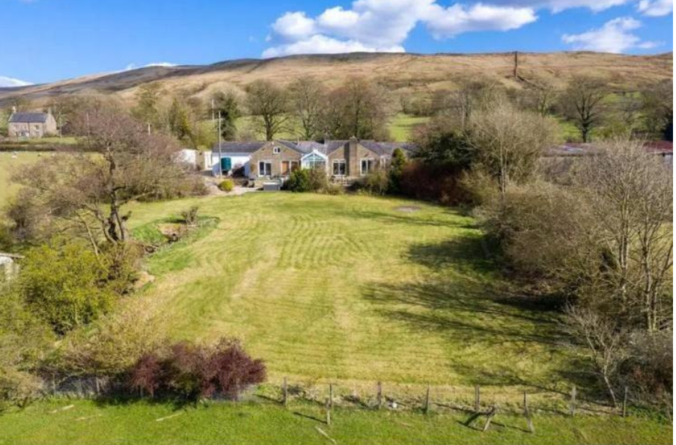

Fig 1. Shows an open watercourse/culvert within the garden of Lynwood.
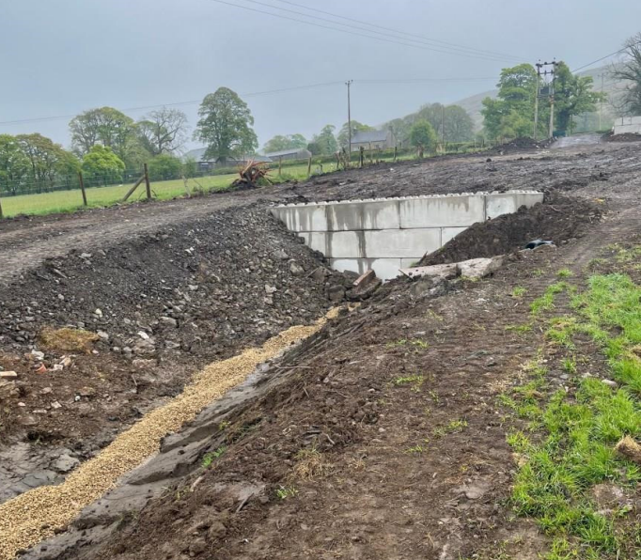

Fig2. Image of former culvert showing development by way of installation of concrete blocks and significant earthworks removal.

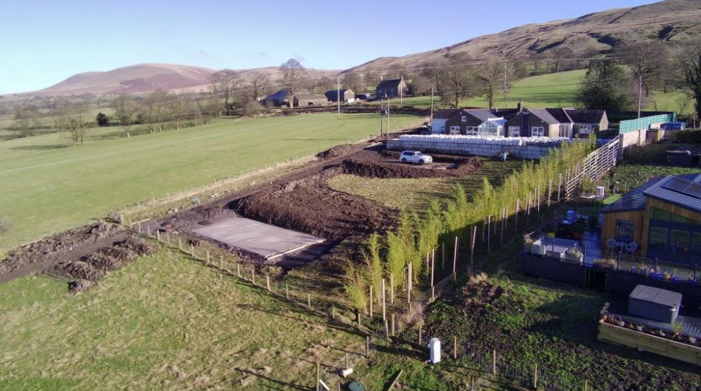

Fig3. Showing extent of raised patio/terraced area across the whole of the rear of the property and extensive earthworks to facilitate the construction/development of concrete bases/hard standings for static lodges.

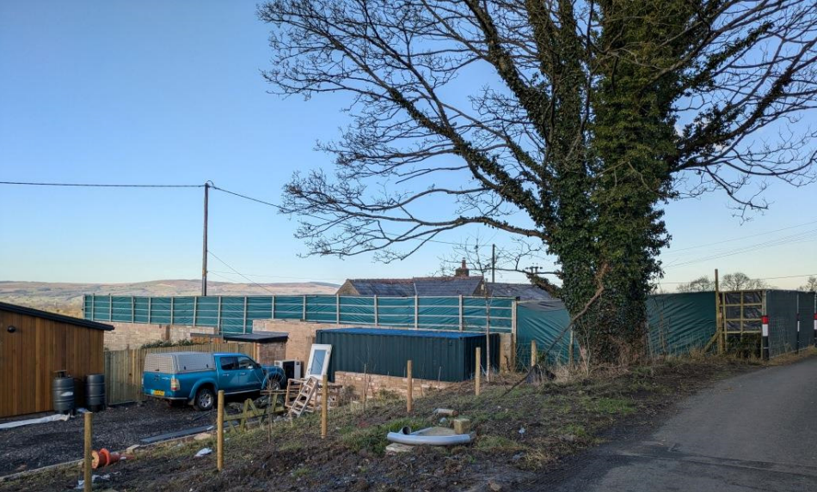
Fig 4. Fencing installed along western boundary above existing boundary wall.
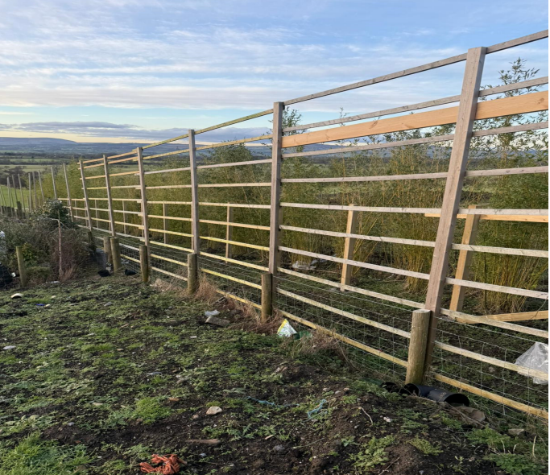

Fig 5. Fencing continued along the western boundary of Lynwood exceeding 2 metres in height.

